Bootstrap 4

Alert

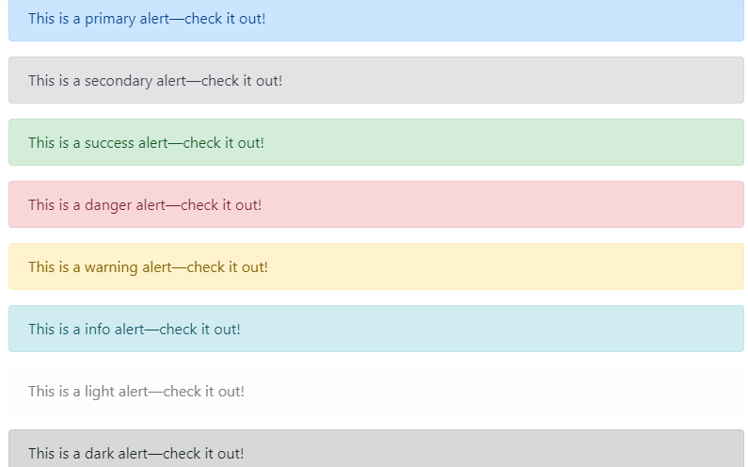

**CODE**

<div class="alert alert-primary" role="alert">

This is a primary alert—check it out!

</div>

<div class="alert alert-secondary" role="alert">

This is a secondary alert—check it out!

</div>

<div class="alert alert-success" role="alert">

This is a success alert—check it out!

</div>

<div class="alert alert-danger" role="alert">

This is a danger alert—check it out!

</div>

<div class="alert alert-warning" role="alert">

This is a warning alert—check it out!

</div>

<div class="alert alert-info" role="alert">

This is a info alert—check it out!

</div>

<div class="alert alert-light" role="alert">

This is a light alert—check it out!

</div>

<div class="alert alert-dark" role="alert">

This is a dark alert—check it out!

</div>

**Link color**

Use the .alert-link utility class to quickly provide matching colored links within any alert.

**Code:**

<div class="alert alert-primary" role="alert">

This is a primary alert with <a href="#" class="alert-link">an example link</a>. Give it a click if you like.

</div>

<div class="alert alert-secondary" role="alert">

This is a secondary alert with <a href="#" class="alert-link">an example link</a>. Give it a click if you like.

</div>

<div class="alert alert-success" role="alert">

This is a success alert with <a href="#" class="alert-link">an example link</a>. Give it a click if you like.

</div>

<div class="alert alert-danger" role="alert">

This is a danger alert with <a href="#" class="alert-link">an example link</a>. Give it a click if you like.

</div>

<div class="alert alert-warning" role="alert">

This is a warning alert with <a href="#" class="alert-link">an example link</a>. Give it a click if you like.

</div>

<div class="alert alert-info" role="alert">

This is a info alert with <a href="#" class="alert-link">an example link</a>. Give it a click if you like.

</div>

<div class="alert alert-light" role="alert">

This is a light alert with <a href="#" class="alert-link">an example link</a>. Give it a click if you like.

</div>

<div class="alert alert-dark" role="alert">

This is a dark alert with <a href="#" class="alert-link">an example link</a>. Give it a click if you like.

</div>

**BADGES**

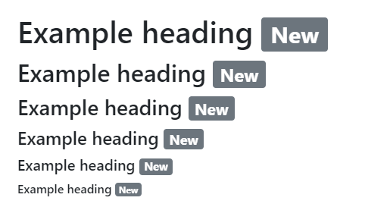

**Code:**

<h1>Example heading <span class="badge badge-secondary">New</span></h1>

<h2>Example heading <span class="badge badge-secondary">New</span></h2>

<h3>Example heading <span class="badge badge-secondary">New</span></h3>

<h4>Example heading <span class="badge badge-secondary">New</span></h4>

<h5>Example heading <span class="badge badge-secondary">New</span></h5>

<h6>Example heading <span class="badge badge-secondary">New</span></h6>



**Code:**

<button type="button" class="btn btn-primary">

Notifications <span class="badge badge-light">4</span>

</button>

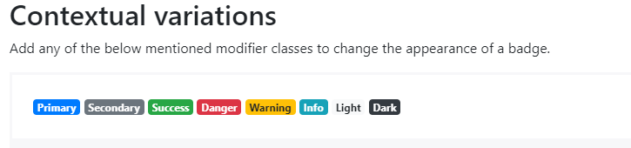

**Code:**

<span class="badge badge-primary">Primary</span>

<span class="badge badge-secondary">Secondary</span>

<span class="badge badge-success">Success</span>

<span class="badge badge-danger">Danger</span>

<span class="badge badge-warning">Warning</span>

<span class="badge badge-info">Info</span>

<span class="badge badge-light">Light</span>

<span class="badge badge-dark">Dark</span>

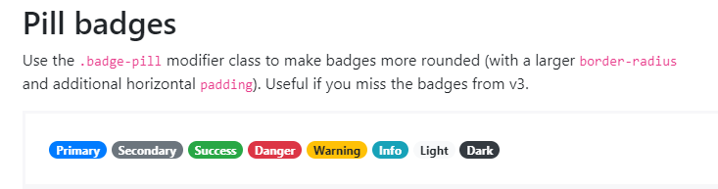

**CODE:**

<span class="badge badge-pill badge-primary">Primary</span>

<span class="badge badge-pill badge-secondary">Secondary</span>

<span class="badge badge-pill badge-success">Success</span>

<span class="badge badge-pill badge-danger">Danger</span>

<span class="badge badge-pill badge-warning">Warning</span>

<span class="badge badge-pill badge-info">Info</span>

<span class="badge badge-pill badge-light">Light</span>

<span class="badge badge-pill badge-dark">Dark</span>

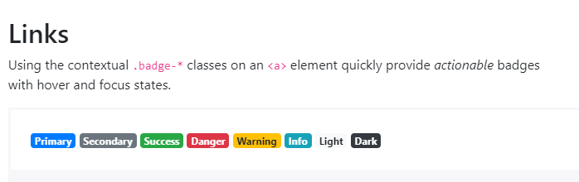

**CODE:**

<a href="#" class="badge badge-primary">Primary</a>

<a href="#" class="badge badge-secondary">Secondary</a>

<a href="#" class="badge badge-success">Success</a>

<a href="#" class="badge badge-danger">Danger</a>

<a href="#" class="badge badge-warning">Warning</a>

<a href="#" class="badge badge-info">Info</a>

<a href="#" class="badge badge-light">Light</a>

<a href="#" class="badge badge-dark">Dark</a>

**Breadcrumb**

**CODE:**

<nav aria-label="breadcrumb">

<ol class="breadcrumb">

<li class="breadcrumb-item active" aria-current="page">Home</li>

</ol>

</nav>

<nav aria-label="breadcrumb">

<ol class="breadcrumb">

<li class="breadcrumb-item"><a href="#">Home</a></li>

<li class="breadcrumb-item active" aria-current="page">Library</li>

</ol>

</nav>

<nav aria-label="breadcrumb">

<ol class="breadcrumb">

<li class="breadcrumb-item"><a href="#">Home</a></li>

<li class="breadcrumb-item"><a href="#">Library</a></li>

<li class="breadcrumb-item active" aria-current="page">Data</li>

</ol>

</nav>

**BUTTONS**

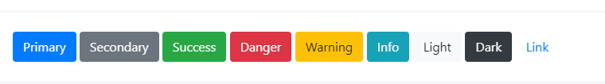

**CODE:**

<button type="button" class="btn btn-primary">Primary</button>

<button type="button" class="btn btn-secondary">Secondary</button>

<button type="button" class="btn btn-success">Success</button>

<button type="button" class="btn btn-danger">Danger</button>

<button type="button" class="btn btn-warning">Warning</button>

<button type="button" class="btn btn-info">Info</button>

<button type="button" class="btn btn-light">Light</button>

<button type="button" class="btn btn-dark">Dark</button>

<button type="button" class="btn btn-link">Link</button>

**CODE:**

<a class="btn btn-primary" href="#" role="button">Link</a>

<button class="btn btn-primary" type="submit">Button</button>

<input class="btn btn-primary" type="button" value="Input">

<input class="btn btn-primary" type="submit" value="Submit">

<input class="btn btn-primary" type="reset" value="Reset">

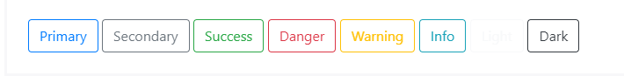

**CODE:**

<button type="button" class="btn btn-outline-primary">Primary</button>

<button type="button" class="btn btn-outline-secondary">Secondary</button>

<button type="button" class="btn btn-outline-success">Success</button>

<button type="button" class="btn btn-outline-danger">Danger</button>

<button type="button" class="btn btn-outline-warning">Warning</button>

<button type="button" class="btn btn-outline-info">Info</button>

<button type="button" class="btn btn-outline-light">Light</button>

<button type="button" class="btn btn-outline-dark">Dark</button>

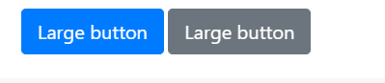

**CODE:**

<button type="button" class="btn btn-primary btn-lg">Large button</button>

<button type="button" class="btn btn-secondary btn-lg">Large button</button>



**CODE:**

<button type="button" class="btn btn-primary btn-sm">Small button</button>

<button type="button" class="btn btn-secondary btn-sm">Small button</button>

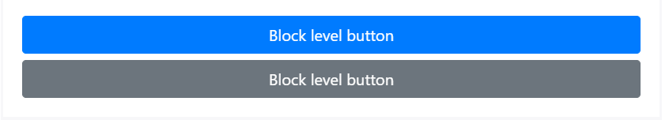

**CODE:**

<button type="button" class="btn btn-primary btn-lg btn-block">Block level button</button>

<button type="button" class="btn btn-secondary btn-lg btn-block">Block level button</button>

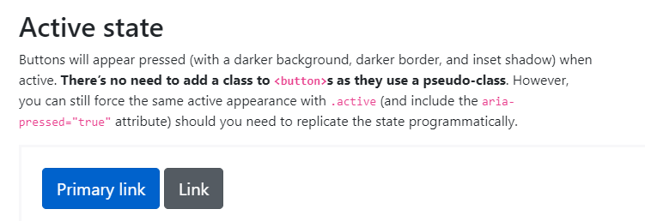

**CODE:**

<a href="#" class="btn btn-primary btn-lg active" role="button" aria-pressed="true">Primary link</a>

<a href="#" class="btn btn-secondary btn-lg active" role="button" aria-pressed="true">Link</a>

**CODE:**

<button type="button" class="btn btn-lg btn-primary" disabled>Primary button</button>

<button type="button" class="btn btn-secondary btn-lg" disabled>Button</button>

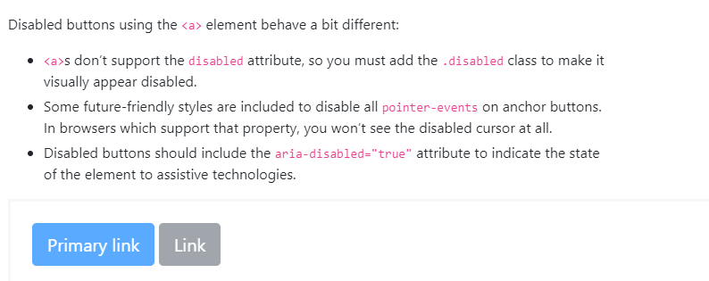

**CODE:**

<a href="#" class="btn btn-primary btn-lg disabled" role="button" aria-disabled="true">Primary link</a>

<a href="#" class="btn btn-secondary btn-lg disabled" role="button" aria-disabled="true">Link</a>

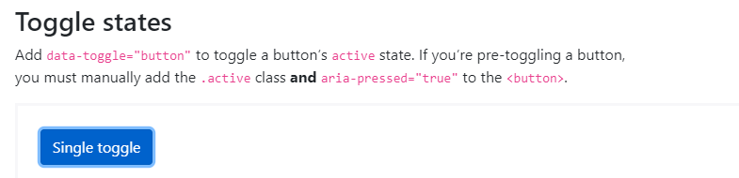

**CODE:**

<button type="button" class="btn btn-primary" data-toggle="button" aria-pressed="false" autocomplete="off">

Single toggle

</button>

**CODE:**

<div class="btn-group-toggle" data-toggle="buttons">

<label class="btn btn-secondary active">

<input type="checkbox" checked autocomplete="off"> Checked

</label>

</div>

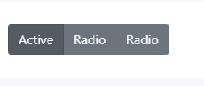

**CODE:**

<div class="btn-group btn-group-toggle" data-toggle="buttons">

<label class="btn btn-secondary active">

<input type="radio" name="options" id="option1" autocomplete="off" checked> Active

</label>

<label class="btn btn-secondary">

<input type="radio" name="options" id="option2" autocomplete="off"> Radio

</label>

<label class="btn btn-secondary">

<input type="radio" name="options" id="option3" autocomplete="off"> Radio

</label>

</div>

**BUTTON GROUPS**

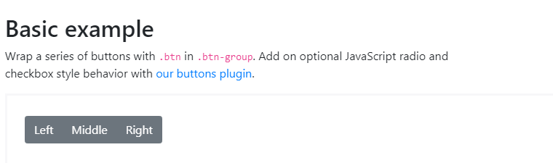

**CODE:**

<div class="btn-group" role="group" aria-label="Basic example">

<button type="button" class="btn btn-secondary">Left</button>

<button type="button" class="btn btn-secondary">Middle</button>

<button type="button" class="btn btn-secondary">Right</button>

</div>

**CODE:**

<div class="btn-toolbar" role="toolbar" aria-label="Toolbar with button groups">

<div class="btn-group mr-2" role="group" aria-label="First group">

<button type="button" class="btn btn-secondary">1</button>

<button type="button" class="btn btn-secondary">2</button>

<button type="button" class="btn btn-secondary">3</button>

<button type="button" class="btn btn-secondary">4</button>

</div>

<div class="btn-group mr-2" role="group" aria-label="Second group">

<button type="button" class="btn btn-secondary">5</button>

<button type="button" class="btn btn-secondary">6</button>

<button type="button" class="btn btn-secondary">7</button>

</div>

<div class="btn-group" role="group" aria-label="Third group">

<button type="button" class="btn btn-secondary">8</button>

</div>

</div>

**CODE:**

<div class="btn-toolbar mb-3" role="toolbar" aria-label="Toolbar with button groups">

<div class="btn-group mr-2" role="group" aria-label="First group">

<button type="button" class="btn btn-secondary">1</button>

<button type="button" class="btn btn-secondary">2</button>

<button type="button" class="btn btn-secondary">3</button>

<button type="button" class="btn btn-secondary">4</button>

</div>

<div class="input-group">

<div class="input-group-prepend">

<div class="input-group-text" id="btnGroupAddon">@</div>

</div>

<input type="text" class="form-control" placeholder="Input group example" aria-label="Input group example" aria-describedby="btnGroupAddon">

</div>

</div>

<div class="btn-toolbar justify-content-between" role="toolbar" aria-label="Toolbar with button groups">

<div class="btn-group" role="group" aria-label="First group">

<button type="button" class="btn btn-secondary">1</button>

<button type="button" class="btn btn-secondary">2</button>

<button type="button" class="btn btn-secondary">3</button>

<button type="button" class="btn btn-secondary">4</button>

</div>

<div class="input-group">

<div class="input-group-prepend">

<div class="input-group-text" id="btnGroupAddon2">@</div>

</div>

<input type="text" class="form-control" placeholder="Input group example" aria-label="Input group example" aria-describedby="btnGroupAddon2">

</div>

</div>

**CODE:**

<div class="btn-group btn-group-lg" role="group" aria-label="...">...</div>

<div class="btn-group" role="group" aria-label="...">...</div>

<div class="btn-group btn-group-sm" role="group" aria-label="...">...</div>

**CODE:**

<div class="btn-group" role="group" aria-label="Button group with nested dropdown">

<button type="button" class="btn btn-secondary">1</button>

<button type="button" class="btn btn-secondary">2</button>

<div class="btn-group" role="group">

<button id="btnGroupDrop1" type="button" class="btn btn-secondary dropdown-toggle" data-toggle="dropdown" aria-haspopup="true" aria-expanded="false">

Dropdown

</button>

<div class="dropdown-menu" aria-labelledby="btnGroupDrop1">

<a class="dropdown-item" href="#">Dropdown link</a>

<a class="dropdown-item" href="#">Dropdown link</a>

</div>

</div>

</div>

**CODE:**

<div class="btn-group-vertical">

...

</div>

**CARDS**

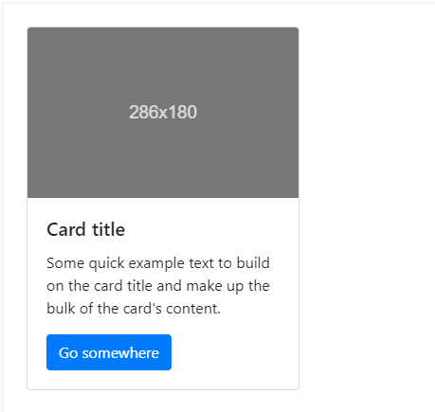

**CODE:**

<div class="card" style="width: 18rem;">

<img class="card-img-top" src="..." alt="Card image cap">

<div class="card-body">

<h5 class="card-title">Card title</h5>

<p class="card-text">Some quick example text to build on the card title and make up the bulk of the card's content.</p>

<a href="#" class="btn btn-primary">Go somewhere</a>

</div>

</div>

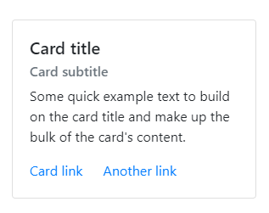

**CODE:**

<div class="card" style="width: 18rem;">

<div class="card-body">

<h5 class="card-title">Card title</h5>

<h6 class="card-subtitle mb-2 text-muted">Card subtitle</h6>

<p class="card-text">Some quick example text to build on the card title and make up the bulk of the card's content.</p>

<a href="#" class="card-link">Card link</a>

<a href="#" class="card-link">Another link</a>

</div>

</div>

**CODE:**

<div class="card" style="width: 18rem;">

<img class="card-img-top" src="..." alt="Card image cap">

<div class="card-body">

<p class="card-text">Some quick example text to build on the card title and make up the bulk of the card's content.</p>

</div>

</div>

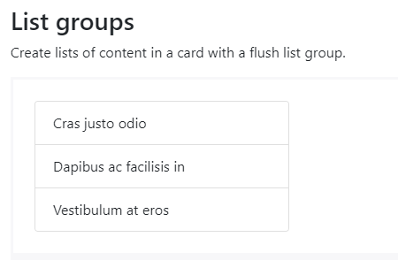

**CODE:**

<div class="card" style="width: 18rem;">

<ul class="list-group list-group-flush">

<li class="list-group-item">Cras justo odio</li>

<li class="list-group-item">Dapibus ac facilisis in</li>

<li class="list-group-item">Vestibulum at eros</li>

</ul>

</div>

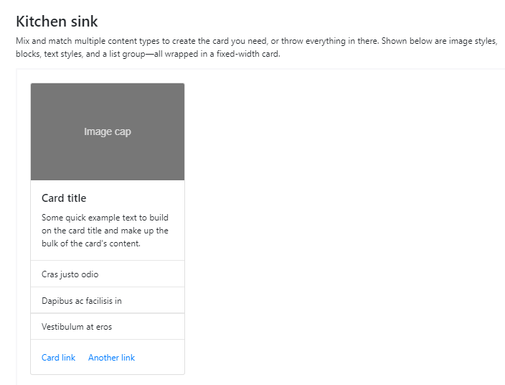

**CODE:**

<div class="card" style="width: 18rem;">

<img class="card-img-top" src="..." alt="Card image cap">

<div class="card-body">

<h5 class="card-title">Card title</h5>

<p class="card-text">Some quick example text to build on the card title and make up the bulk of the card's content.</p>

</div>

<ul class="list-group list-group-flush">

<li class="list-group-item">Cras justo odio</li>

<li class="list-group-item">Dapibus ac facilisis in</li>

<li class="list-group-item">Vestibulum at eros</li>

</ul>

<div class="card-body">

<a href="#" class="card-link">Card link</a>

<a href="#" class="card-link">Another link</a>

</div>

</div>

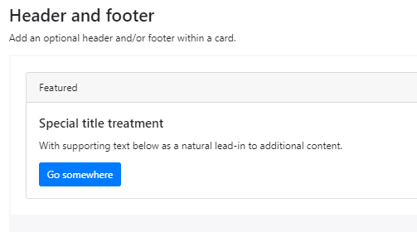

**CODE:**

<div class="card">

<div class="card-header">

Featured

</div>

<div class="card-body">

<h5 class="card-title">Special title treatment</h5>

<p class="card-text">With supporting text below as a natural lead-in to additional content.</p>

<a href="#" class="btn btn-primary">Go somewhere</a>

</div>

</div>

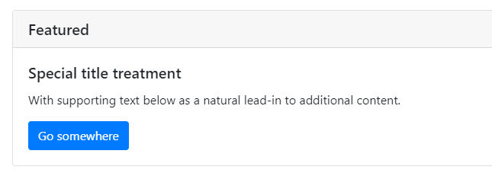

**CODE:**

<div class="card">

<h5 class="card-header">Featured</h5>

<div class="card-body">

<h5 class="card-title">Special title treatment</h5>

<p class="card-text">With supporting text below as a natural lead-in to additional content.</p>

<a href="#" class="btn btn-primary">Go somewhere</a>

</div>

</div>

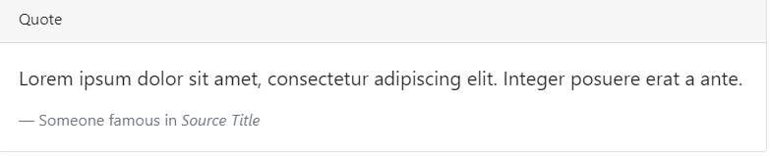

**CODE:**

<div class="card">

<div class="card-header">

Quote

</div>

<div class="card-body">

<blockquote class="blockquote mb-0">

<p>Lorem ipsum dolor sit amet, consectetur adipiscing elit. Integer posuere erat a ante.</p>

<footer class="blockquote-footer">Someone famous in <cite title="Source Title">Source Title</cite></footer>

</blockquote>

</div>

</div>

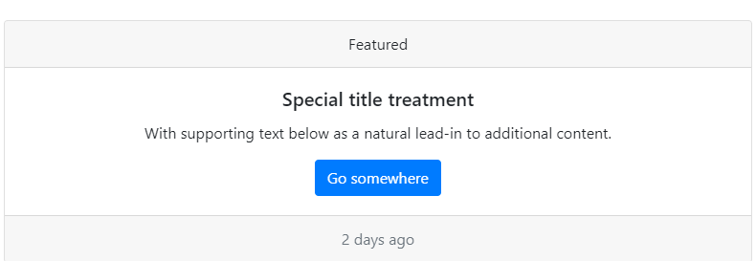

**CODE:**

<div class="card text-center">

<div class="card-header">

Featured

</div>

<div class="card-body">

<h5 class="card-title">Special title treatment</h5>

<p class="card-text">With supporting text below as a natural lead-in to additional content.</p>

<a href="#" class="btn btn-primary">Go somewhere</a>

</div>

<div class="card-footer text-muted">

2 days ago

</div>

</div>

**CODE:**

<div class="row">

<div class="col-sm-6">

<div class="card">

<div class="card-body">

<h5 class="card-title">Special title treatment</h5>

<p class="card-text">With supporting text below as a natural lead-in to additional content.</p>

<a href="#" class="btn btn-primary">Go somewhere</a>

</div>

</div>

</div>

<div class="col-sm-6">

<div class="card">

<div class="card-body">

<h5 class="card-title">Special title treatment</h5>

<p class="card-text">With supporting text below as a natural lead-in to additional content.</p>

<a href="#" class="btn btn-primary">Go somewhere</a>

</div>

</div>

</div>

</div>

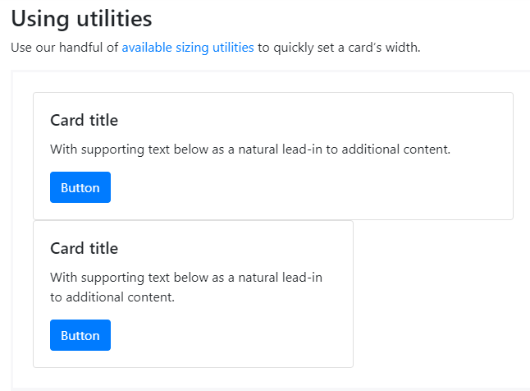

**CODE:**

<div class="card w-75">

<div class="card-body">

<h5 class="card-title">Card title</h5>

<p class="card-text">With supporting text below as a natural lead-in to additional content.</p>

<a href="#" class="btn btn-primary">Button</a>

</div>

</div>

<div class="card w-50">

<div class="card-body">

<h5 class="card-title">Card title</h5>

<p class="card-text">With supporting text below as a natural lead-in to additional content.</p>

<a href="#" class="btn btn-primary">Button</a>

</div>

</div>

<div class="card" style="width: 18rem;">

<div class="card-body">

<h5 class="card-title">Special title treatment</h5>

<p class="card-text">With supporting text below as a natural lead-in to additional content.</p>

<a href="#" class="btn btn-primary">Go somewhere</a>

</div>

</div>

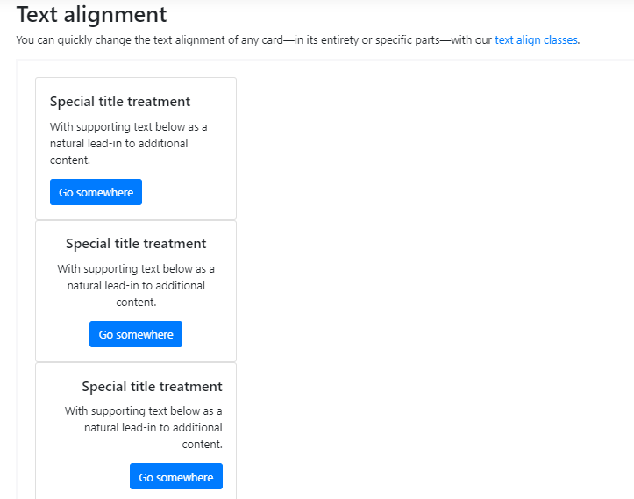

**CODE:**

<div class="card" style="width: 18rem;">

<div class="card-body">

<h5 class="card-title">Special title treatment</h5>

<p class="card-text">With supporting text below as a natural lead-in to additional content.</p>

<a href="#" class="btn btn-primary">Go somewhere</a>

</div>

</div>

<div class="card text-center" style="width: 18rem;">

<div class="card-body">

<h5 class="card-title">Special title treatment</h5>

<p class="card-text">With supporting text below as a natural lead-in to additional content.</p>

<a href="#" class="btn btn-primary">Go somewhere</a>

</div>

</div>

<div class="card text-right" style="width: 18rem;">

<div class="card-body">

<h5 class="card-title">Special title treatment</h5>

<p class="card-text">With supporting text below as a natural lead-in to additional content.</p>

<a href="#" class="btn btn-primary">Go somewhere</a>

</div>

</div>

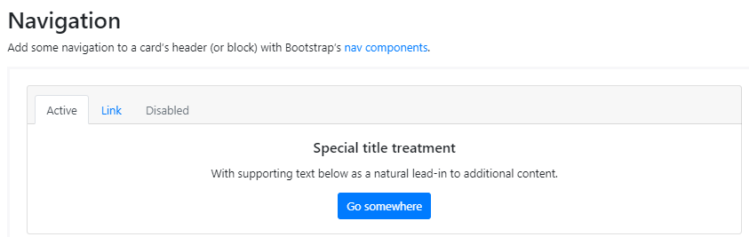

**CODE:**

<div class="card text-center">

<div class="card-header">

<ul class="nav nav-tabs card-header-tabs">

<li class="nav-item">

<a class="nav-link active" href="#">Active</a>

</li>

<li class="nav-item">

<a class="nav-link" href="#">Link</a>

</li>

<li class="nav-item">

<a class="nav-link disabled" href="#">Disabled</a>

</li>

</ul>

</div>

<div class="card-body">

<h5 class="card-title">Special title treatment</h5>

<p class="card-text">With supporting text below as a natural lead-in to additional content.</p>

<a href="#" class="btn btn-primary">Go somewhere</a>

</div>

</div>

**CODE:**

<div class="card text-center">

<div class="card-header">

<ul class="nav nav-pills card-header-pills">

<li class="nav-item">

<a class="nav-link active" href="#">Active</a>

</li>

<li class="nav-item">

<a class="nav-link" href="#">Link</a>

</li>

<li class="nav-item">

<a class="nav-link disabled" href="#">Disabled</a>

</li>

</ul>

</div>

<div class="card-body">

<h5 class="card-title">Special title treatment</h5>

<p class="card-text">With supporting text below as a natural lead-in to additional content.</p>

<a href="#" class="btn btn-primary">Go somewhere</a>

</div>

</div>

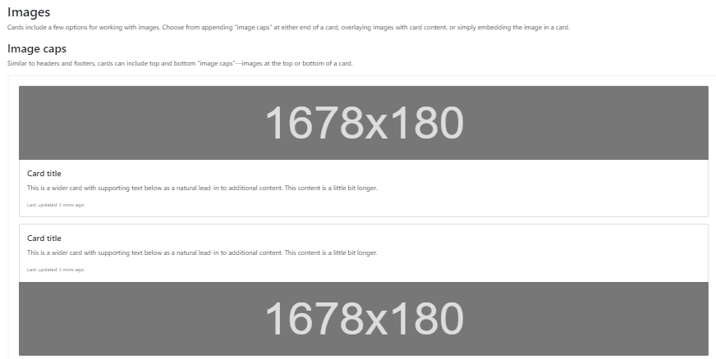

**CODE:**

<div class="card mb-3">

<img class="card-img-top" src="..." alt="Card image cap">

<div class="card-body">

<h5 class="card-title">Card title</h5>

<p class="card-text">This is a wider card with supporting text below as a natural lead-in to additional content. This content is a little bit longer.</p>

<p class="card-text"><small class="text-muted">Last updated 3 mins ago</small></p>

</div>

</div>

<div class="card">

<div class="card-body">

<h5 class="card-title">Card title</h5>

<p class="card-text">This is a wider card with supporting text below as a natural lead-in to additional content. This content is a little bit longer.</p>

<p class="card-text"><small class="text-muted">Last updated 3 mins ago</small></p>

</div>

<img class="card-img-bottom" src="..." alt="Card image cap">

</div>

**CODE:**

<div class="card bg-dark text-white">

<img class="card-img" src="..." alt="Card image">

<div class="card-img-overlay">

<h5 class="card-title">Card title</h5>

<p class="card-text">This is a wider card with supporting text below as a natural lead-in to additional content. This content is a little bit longer.</p>

<p class="card-text">Last updated 3 mins ago</p>

</div>

</div>

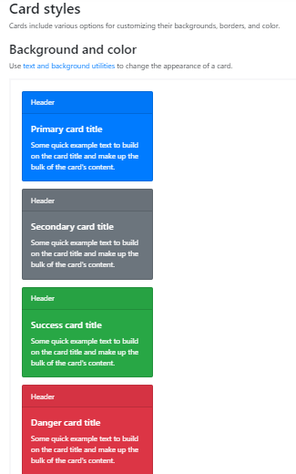

**CODE:**

<div class="card text-white bg-primary mb-3" style="max-width: 18rem;">

<div class="card-header">Header</div>

<div class="card-body">

<h5 class="card-title">Primary card title</h5>

<p class="card-text">Some quick example text to build on the card title and make up the bulk of the card's content.</p>

</div>

</div>

<div class="card text-white bg-secondary mb-3" style="max-width: 18rem;">

<div class="card-header">Header</div>

<div class="card-body">

<h5 class="card-title">Secondary card title</h5>

<p class="card-text">Some quick example text to build on the card title and make up the bulk of the card's content.</p>

</div>

</div>

<div class="card text-white bg-success mb-3" style="max-width: 18rem;">

<div class="card-header">Header</div>

<div class="card-body">

<h5 class="card-title">Success card title</h5>

<p class="card-text">Some quick example text to build on the card title and make up the bulk of the card's content.</p>

</div>

</div>

<div class="card text-white bg-danger mb-3" style="max-width: 18rem;">

<div class="card-header">Header</div>

<div class="card-body">

<h5 class="card-title">Danger card title</h5>

<p class="card-text">Some quick example text to build on the card title and make up the bulk of the card's content.</p>

</div>

</div>

<div class="card text-white bg-warning mb-3" style="max-width: 18rem;">

<div class="card-header">Header</div>

<div class="card-body">

<h5 class="card-title">Warning card title</h5>

<p class="card-text">Some quick example text to build on the card title and make up the bulk of the card's content.</p>

</div>

</div>

<div class="card text-white bg-info mb-3" style="max-width: 18rem;">

<div class="card-header">Header</div>

<div class="card-body">

<h5 class="card-title">Info card title</h5>

<p class="card-text">Some quick example text to build on the card title and make up the bulk of the card's content.</p>

</div>

</div>

<div class="card bg-light mb-3" style="max-width: 18rem;">

<div class="card-header">Header</div>

<div class="card-body">

<h5 class="card-title">Light card title</h5>

<p class="card-text">Some quick example text to build on the card title and make up the bulk of the card's content.</p>

</div>

</div>

<div class="card text-white bg-dark mb-3" style="max-width: 18rem;">

<div class="card-header">Header</div>

<div class="card-body">

<h5 class="card-title">Dark card title</h5>

<p class="card-text">Some quick example text to build on the card title and make up the bulk of the card's content.</p>

</div>

</div>

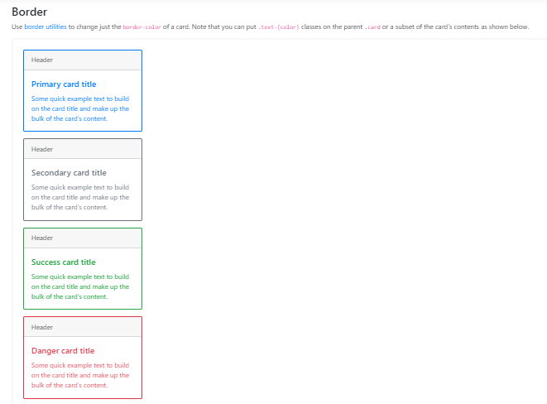

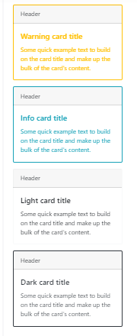

**CODE:**

<div class="card border-primary mb-3" style="max-width: 18rem;">

<div class="card-header">Header</div>

<div class="card-body text-primary">

<h5 class="card-title">Primary card title</h5>

<p class="card-text">Some quick example text to build on the card title and make up the bulk of the card's content.</p>

</div>

</div>

<div class="card border-secondary mb-3" style="max-width: 18rem;">

<div class="card-header">Header</div>

<div class="card-body text-secondary">

<h5 class="card-title">Secondary card title</h5>

<p class="card-text">Some quick example text to build on the card title and make up the bulk of the card's content.</p>

</div>

</div>

<div class="card border-success mb-3" style="max-width: 18rem;">

<div class="card-header">Header</div>

<div class="card-body text-success">

<h5 class="card-title">Success card title</h5>

<p class="card-text">Some quick example text to build on the card title and make up the bulk of the card's content.</p>

</div>

</div>

<div class="card border-danger mb-3" style="max-width: 18rem;">

<div class="card-header">Header</div>

<div class="card-body text-danger">

<h5 class="card-title">Danger card title</h5>

<p class="card-text">Some quick example text to build on the card title and make up the bulk of the card's content.</p>

</div>

</div>

<div class="card border-warning mb-3" style="max-width: 18rem;">

<div class="card-header">Header</div>

<div class="card-body text-warning">

<h5 class="card-title">Warning card title</h5>

<p class="card-text">Some quick example text to build on the card title and make up the bulk of the card's content.</p>

</div>

</div>

<div class="card border-info mb-3" style="max-width: 18rem;">

<div class="card-header">Header</div>

<div class="card-body text-info">

<h5 class="card-title">Info card title</h5>

<p class="card-text">Some quick example text to build on the card title and make up the bulk of the card's content.</p>

</div>

</div>

<div class="card border-light mb-3" style="max-width: 18rem;">

<div class="card-header">Header</div>

<div class="card-body">

<h5 class="card-title">Light card title</h5>

<p class="card-text">Some quick example text to build on the card title and make up the bulk of the card's content.</p>

</div>

</div>

<div class="card border-dark mb-3" style="max-width: 18rem;">

<div class="card-header">Header</div>

<div class="card-body text-dark">

<h5 class="card-title">Dark card title</h5>

<p class="card-text">Some quick example text to build on the card title and make up the bulk of the card's content.</p>

</div>

</div>

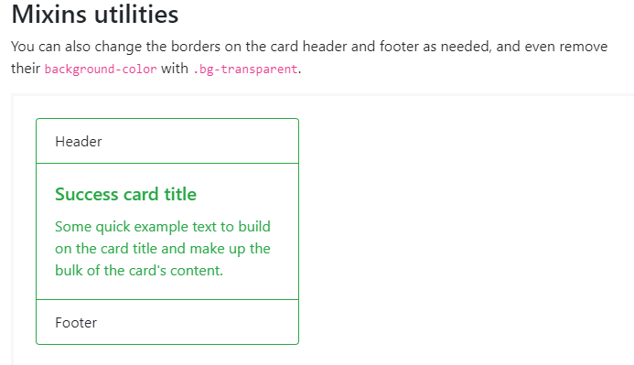

**CODE:**

<div class="card border-success mb-3" style="max-width: 18rem;">

<div class="card-header bg-transparent border-success">Header</div>

<div class="card-body text-success">

<h5 class="card-title">Success card title</h5>

<p class="card-text">Some quick example text to build on the card title and make up the bulk of the card's content.</p>

</div>

<div class="card-footer bg-transparent border-success">Footer</div>

</div>

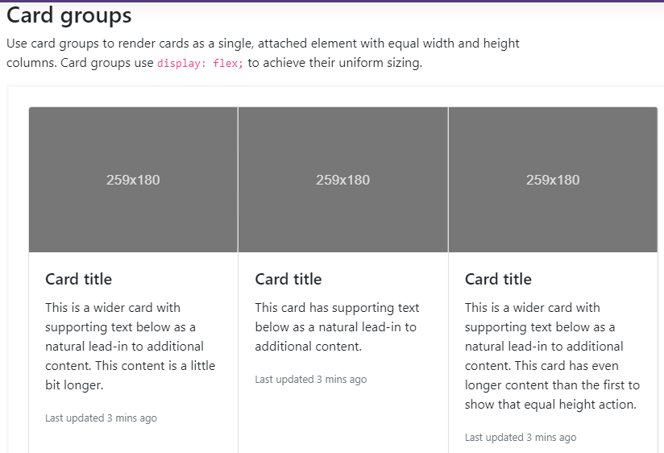

**CODE:**

<div class="card-group">

<div class="card">

<img class="card-img-top" src="..." alt="Card image cap">

<div class="card-body">

<h5 class="card-title">Card title</h5>

<p class="card-text">This is a wider card with supporting text below as a natural lead-in to additional content. This content is a little bit longer.</p>

<p class="card-text"><small class="text-muted">Last updated 3 mins ago</small></p>

</div>

</div>

<div class="card">

<img class="card-img-top" src="..." alt="Card image cap">

<div class="card-body">

<h5 class="card-title">Card title</h5>

<p class="card-text">This card has supporting text below as a natural lead-in to additional content.</p>

<p class="card-text"><small class="text-muted">Last updated 3 mins ago</small></p>

</div>

</div>

<div class="card">

<img class="card-img-top" src="..." alt="Card image cap">

<div class="card-body">

<h5 class="card-title">Card title</h5>

<p class="card-text">This is a wider card with supporting text below as a natural lead-in to additional content. This card has even longer content than the first to show that equal height action.</p>

<p class="card-text"><small class="text-muted">Last updated 3 mins ago</small></p>

</div>

</div>

</div>

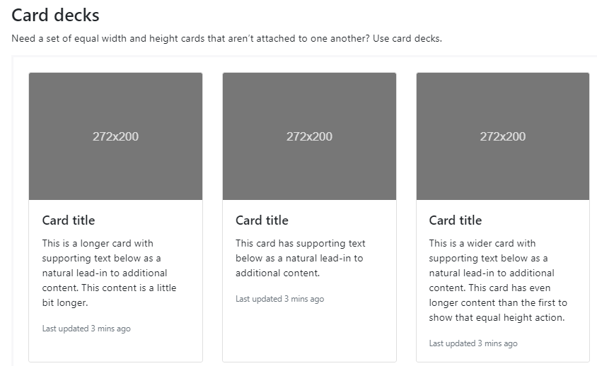

**CODE:**

<div class="card-deck">

<div class="card">

<img class="card-img-top" src="..." alt="Card image cap">

<div class="card-body">

<h5 class="card-title">Card title</h5>

<p class="card-text">This is a longer card with supporting text below as a natural lead-in to additional content. This content is a little bit longer.</p>

<p class="card-text"><small class="text-muted">Last updated 3 mins ago</small></p>

</div>

</div>

<div class="card">

<img class="card-img-top" src="..." alt="Card image cap">

<div class="card-body">

<h5 class="card-title">Card title</h5>

<p class="card-text">This card has supporting text below as a natural lead-in to additional content.</p>

<p class="card-text"><small class="text-muted">Last updated 3 mins ago</small></p>

</div>

</div>

<div class="card">

<img class="card-img-top" src="..." alt="Card image cap">

<div class="card-body">

<h5 class="card-title">Card title</h5>

<p class="card-text">This is a wider card with supporting text below as a natural lead-in to additional content. This card has even longer content than the first to show that equal height action.</p>

<p class="card-text"><small class="text-muted">Last updated 3 mins ago</small></p>

</div>

</div>

</div>

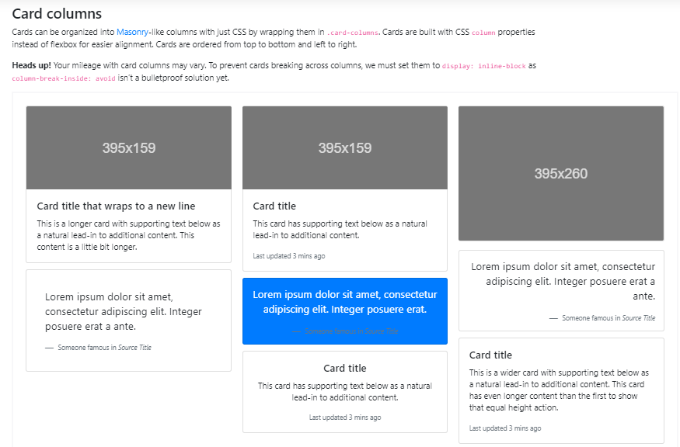

**CODE:**

<div class="card-columns">

<div class="card">

<img class="card-img-top" src="..." alt="Card image cap">

<div class="card-body">

<h5 class="card-title">Card title that wraps to a new line</h5>

<p class="card-text">This is a longer card with supporting text below as a natural lead-in to additional content. This content is a little bit longer.</p>

</div>

</div>

<div class="card p-3">

<blockquote class="blockquote mb-0 card-body">

<p>Lorem ipsum dolor sit amet, consectetur adipiscing elit. Integer posuere erat a ante.</p>

<footer class="blockquote-footer">

<small class="text-muted">

Someone famous in <cite title="Source Title">Source Title</cite>

</small>

</footer>

</blockquote>

</div>

<div class="card">

<img class="card-img-top" src="..." alt="Card image cap">

<div class="card-body">

<h5 class="card-title">Card title</h5>

<p class="card-text">This card has supporting text below as a natural lead-in to additional content.</p>

<p class="card-text"><small class="text-muted">Last updated 3 mins ago</small></p>

</div>

</div>

<div class="card bg-primary text-white text-center p-3">

<blockquote class="blockquote mb-0">

<p>Lorem ipsum dolor sit amet, consectetur adipiscing elit. Integer posuere erat.</p>

<footer class="blockquote-footer">

<small>

Someone famous in <cite title="Source Title">Source Title</cite>

</small>

</footer>

</blockquote>

</div>

<div class="card text-center">

<div class="card-body">

<h5 class="card-title">Card title</h5>

<p class="card-text">This card has supporting text below as a natural lead-in to additional content.</p>

<p class="card-text"><small class="text-muted">Last updated 3 mins ago</small></p>

</div>

</div>

<div class="card">

<img class="card-img" src="..." alt="Card image">

</div>

<div class="card p-3 text-right">

<blockquote class="blockquote mb-0">

<p>Lorem ipsum dolor sit amet, consectetur adipiscing elit. Integer posuere erat a ante.</p>

<footer class="blockquote-footer">

<small class="text-muted">

Someone famous in <cite title="Source Title">Source Title</cite>

</small>

</footer>

</blockquote>

</div>

<div class="card">

<div class="card-body">

<h5 class="card-title">Card title</h5>

<p class="card-text">This is a wider card with supporting text below as a natural lead-in to additional content. This card has even longer content than the first to show that equal height action.</p>

<p class="card-text"><small class="text-muted">Last updated 3 mins ago</small></p>

</div>

</div>

</div>

**CAROUSEL**

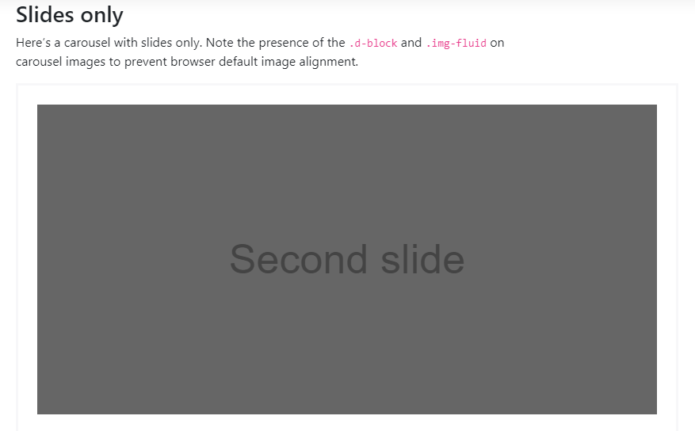

**CODE:**

<div id="carouselExampleSlidesOnly" class="carousel slide" data-ride="carousel">

<div class="carousel-inner">

<div class="carousel-item active">

<img class="d-block w-100" src="..." alt="First slide">

</div>

<div class="carousel-item">

<img class="d-block w-100" src="..." alt="Second slide">

</div>

<div class="carousel-item">

<img class="d-block w-100" src="..." alt="Third slide">

</div>

</div>

</div>

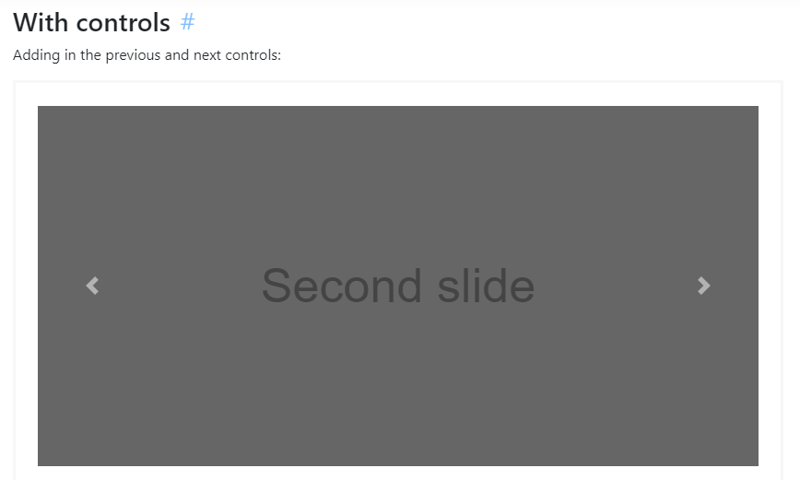

**CODE:**

<div id="carouselExampleControls" class="carousel slide" data-ride="carousel">

<div class="carousel-inner">

<div class="carousel-item active">

<img class="d-block w-100" src="..." alt="First slide">

</div>

<div class="carousel-item">

<img class="d-block w-100" src="..." alt="Second slide">

</div>

<div class="carousel-item">

<img class="d-block w-100" src="..." alt="Third slide">

</div>

</div>

<a class="carousel-control-prev" href="#carouselExampleControls" role="button" data-slide="prev">

<span class="carousel-control-prev-icon" aria-hidden="true"></span>

<span class="sr-only">Previous</span>

</a>

<a class="carousel-control-next" href="#carouselExampleControls" role="button" data-slide="next">

<span class="carousel-control-next-icon" aria-hidden="true"></span>

<span class="sr-only">Next</span>

</a>

</div>

**CODE:**

<div id="carouselExampleIndicators" class="carousel slide" data-ride="carousel">

<ol class="carousel-indicators">

<li data-target="#carouselExampleIndicators" data-slide-to="0" class="active"></li>

<li data-target="#carouselExampleIndicators" data-slide-to="1"></li>

<li data-target="#carouselExampleIndicators" data-slide-to="2"></li>

</ol>

<div class="carousel-inner">

<div class="carousel-item active">

<img class="d-block w-100" src="..." alt="First slide">

</div>

<div class="carousel-item">

<img class="d-block w-100" src="..." alt="Second slide">

</div>

<div class="carousel-item">

<img class="d-block w-100" src="..." alt="Third slide">

</div>

</div>

<a class="carousel-control-prev" href="#carouselExampleIndicators" role="button" data-slide="prev">

<span class="carousel-control-prev-icon" aria-hidden="true"></span>

<span class="sr-only">Previous</span>

</a>

<a class="carousel-control-next" href="#carouselExampleIndicators" role="button" data-slide="next">

<span class="carousel-control-next-icon" aria-hidden="true"></span>

<span class="sr-only">Next</span>

</a>

</div>

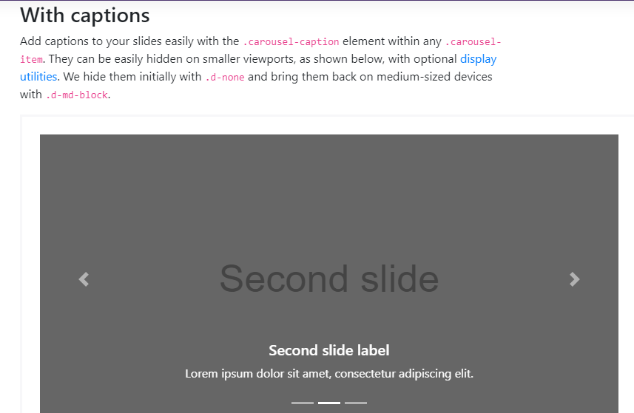

**CODE:**

<div class="carousel-item">

<img src="..." alt="...">

<div class="carousel-caption d-none d-md-block">

<h5>...</h5>

<p>...</p>

</div>

</div>

**COLLAPSE**

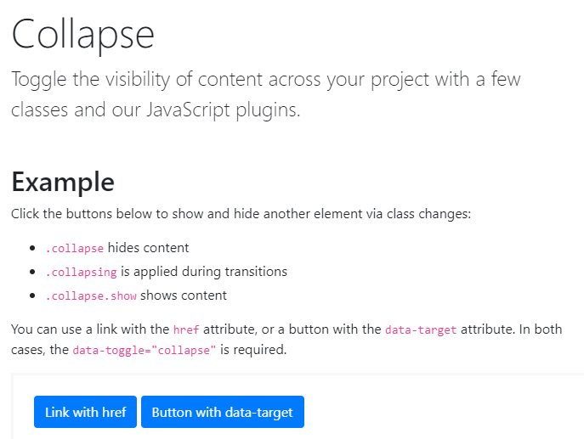

**CODE:**

<p>

<a class="btn btn-primary" data-toggle="collapse" href="#collapseExample" role="button" aria-expanded="false" aria-controls="collapseExample">

Link with href

</a>

<button class="btn btn-primary" type="button" data-toggle="collapse" data-target="#collapseExample" aria-expanded="false" aria-controls="collapseExample">

Button with data-target

</button>

</p>

<div class="collapse" id="collapseExample">

<div class="card card-body">

Anim pariatur cliche reprehenderit, enim eiusmod high life accusamus terry richardson ad squid. Nihil anim keffiyeh helvetica, craft beer labore wes anderson cred nesciunt sapiente ea proident.

</div>

</div>

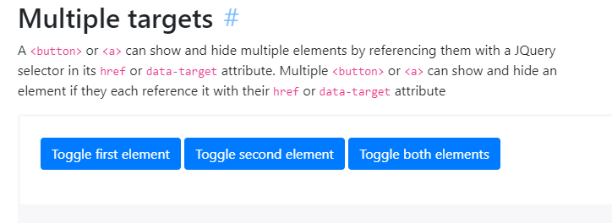

**CODE:**

<p>

<a class="btn btn-primary" data-toggle="collapse" href="#multiCollapseExample1" role="button" aria-expanded="false" aria-controls="multiCollapseExample1">Toggle first element</a>

<button class="btn btn-primary" type="button" data-toggle="collapse" data-target="#multiCollapseExample2" aria-expanded="false" aria-controls="multiCollapseExample2">Toggle second element</button>

<button class="btn btn-primary" type="button" data-toggle="collapse" data-target=".multi-collapse" aria-expanded="false" aria-controls="multiCollapseExample1 multiCollapseExample2">Toggle both elements</button>

</p>

<div class="row">

<div class="col">

<div class="collapse multi-collapse" id="multiCollapseExample1">

<div class="card card-body">

Anim pariatur cliche reprehenderit, enim eiusmod high life accusamus terry richardson ad squid. Nihil anim keffiyeh helvetica, craft beer labore wes anderson cred nesciunt sapiente ea proident.

</div>

</div>

</div>

<div class="col">

<div class="collapse multi-collapse" id="multiCollapseExample2">

<div class="card card-body">

Anim pariatur cliche reprehenderit, enim eiusmod high life accusamus terry richardson ad squid. Nihil anim keffiyeh helvetica, craft beer labore wes anderson cred nesciunt sapiente ea proident.

</div>

</div>

</div>

</div>

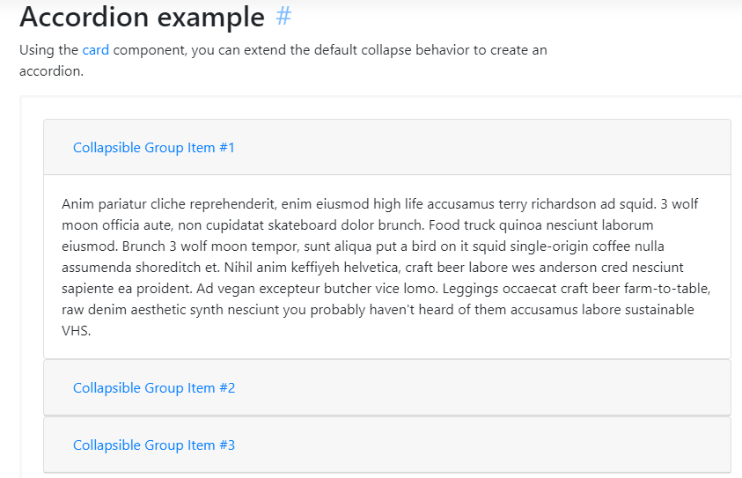

**CODE:**

<div id="accordion">

<div class="card">

<div class="card-header" id="headingOne">

<h5 class="mb-0">

<button class="btn btn-link" data-toggle="collapse" data-target="#collapseOne" aria-expanded="true" aria-controls="collapseOne">

Collapsible Group Item #1

</button>

</h5>

</div>

<div id="collapseOne" class="collapse show" aria-labelledby="headingOne" data-parent="#accordion">

<div class="card-body">

Anim pariatur cliche reprehenderit, enim eiusmod high life accusamus terry richardson ad squid. 3 wolf moon officia aute, non cupidatat skateboard dolor brunch. Food truck quinoa nesciunt laborum eiusmod. Brunch 3 wolf moon tempor, sunt aliqua put a bird on it squid single-origin coffee nulla assumenda shoreditch et. Nihil anim keffiyeh helvetica, craft beer labore wes anderson cred nesciunt sapiente ea proident. Ad vegan excepteur butcher vice lomo. Leggings occaecat craft beer farm-to-table, raw denim aesthetic synth nesciunt you probably haven't heard of them accusamus labore sustainable VHS.

</div>

</div>

</div>

<div class="card">

<div class="card-header" id="headingTwo">

<h5 class="mb-0">

<button class="btn btn-link collapsed" data-toggle="collapse" data-target="#collapseTwo" aria-expanded="false" aria-controls="collapseTwo">

Collapsible Group Item #2

</button>

</h5>

</div>

<div id="collapseTwo" class="collapse" aria-labelledby="headingTwo" data-parent="#accordion">

<div class="card-body">

Anim pariatur cliche reprehenderit, enim eiusmod high life accusamus terry richardson ad squid. 3 wolf moon officia aute, non cupidatat skateboard dolor brunch. Food truck quinoa nesciunt laborum eiusmod. Brunch 3 wolf moon tempor, sunt aliqua put a bird on it squid single-origin coffee nulla assumenda shoreditch et. Nihil anim keffiyeh helvetica, craft beer labore wes anderson cred nesciunt sapiente ea proident. Ad vegan excepteur butcher vice lomo. Leggings occaecat craft beer farm-to-table, raw denim aesthetic synth nesciunt you probably haven't heard of them accusamus labore sustainable VHS.

</div>

</div>

</div>

<div class="card">

<div class="card-header" id="headingThree">

<h5 class="mb-0">

<button class="btn btn-link collapsed" data-toggle="collapse" data-target="#collapseThree" aria-expanded="false" aria-controls="collapseThree">

Collapsible Group Item #3

</button>

</h5>

</div>

<div id="collapseThree" class="collapse" aria-labelledby="headingThree" data-parent="#accordion">

<div class="card-body">

Anim pariatur cliche reprehenderit, enim eiusmod high life accusamus terry richardson ad squid. 3 wolf moon officia aute, non cupidatat skateboard dolor brunch. Food truck quinoa nesciunt laborum eiusmod. Brunch 3 wolf moon tempor, sunt aliqua put a bird on it squid single-origin coffee nulla assumenda shoreditch et. Nihil anim keffiyeh helvetica, craft beer labore wes anderson cred nesciunt sapiente ea proident. Ad vegan excepteur butcher vice lomo. Leggings occaecat craft beer farm-to-table, raw denim aesthetic synth nesciunt you probably haven't heard of them accusamus labore sustainable VHS.

</div>

</div>

</div>

</div>

**DROPDOWNS**

**CODE:**

<div class="dropdown">

<button class="btn btn-secondary dropdown-toggle" type="button" id="dropdownMenuButton" data-toggle="dropdown" aria-haspopup="true" aria-expanded="false">

Dropdown button

</button>

<div class="dropdown-menu" aria-labelledby="dropdownMenuButton">

<a class="dropdown-item" href="#">Action</a>

<a class="dropdown-item" href="#">Another action</a>

<a class="dropdown-item" href="#">Something else here</a>

</div>

</div>

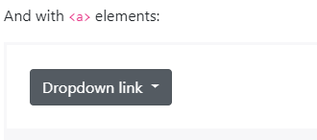

**CODE:**

<div class="dropdown show">

<a class="btn btn-secondary dropdown-toggle" href="#" role="button" id="dropdownMenuLink" data-toggle="dropdown" aria-haspopup="true" aria-expanded="false">

Dropdown link

</a>

<div class="dropdown-menu" aria-labelledby="dropdownMenuLink">

<a class="dropdown-item" href="#">Action</a>

<a class="dropdown-item" href="#">Another action</a>

<a class="dropdown-item" href="#">Something else here</a>

</div>

</div>

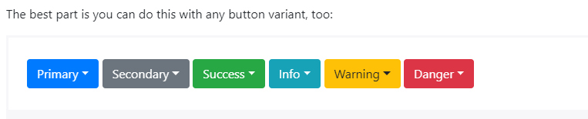

**CODE:**

<!-- Example single danger button -->

<div class="btn-group">

<button type="button" class="btn btn-danger dropdown-toggle" data-toggle="dropdown" aria-haspopup="true" aria-expanded="false">

Action

</button>

<div class="dropdown-menu">

<a class="dropdown-item" href="#">Action</a>

<a class="dropdown-item" href="#">Another action</a>

<a class="dropdown-item" href="#">Something else here</a>

<div class="dropdown-divider"></div>

<a class="dropdown-item" href="#">Separated link</a>

</div>

</div>

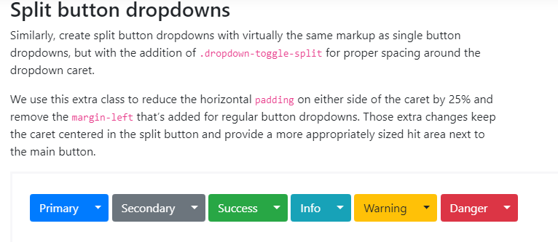

**CODE:**

<!-- Example split danger button -->

<div class="btn-group">

<button type="button" class="btn btn-danger">Action</button>

<button type="button" class="btn btn-danger dropdown-toggle dropdown-toggle-split" data-toggle="dropdown" aria-haspopup="true" aria-expanded="false">

<span class="sr-only">Toggle Dropdown</span>

</button>

<div class="dropdown-menu">

<a class="dropdown-item" href="#">Action</a>

<a class="dropdown-item" href="#">Another action</a>

<a class="dropdown-item" href="#">Something else here</a>

<div class="dropdown-divider"></div>

<a class="dropdown-item" href="#">Separated link</a>

</div>

</div>

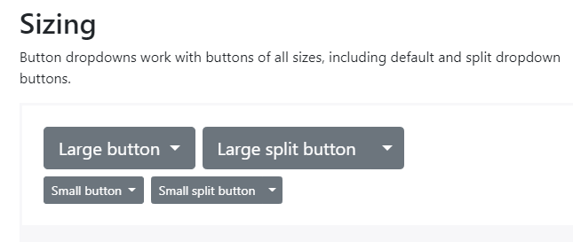

**CODE:**

<!-- Large button groups (default and split) -->

<div class="btn-group">

<button class="btn btn-secondary btn-lg dropdown-toggle" type="button" data-toggle="dropdown" aria-haspopup="true" aria-expanded="false">

Large button

</button>

<div class="dropdown-menu">

...

</div>

</div>

<div class="btn-group">

<button class="btn btn-secondary btn-lg" type="button">

Large split button

</button>

<button type="button" class="btn btn-lg btn-secondary dropdown-toggle dropdown-toggle-split" data-toggle="dropdown" aria-haspopup="true" aria-expanded="false">

<span class="sr-only">Toggle Dropdown</span>

</button>

<div class="dropdown-menu">

...

</div>

</div>

<!-- Small button groups (default and split) -->

<div class="btn-group">

<button class="btn btn-secondary btn-sm dropdown-toggle" type="button" data-toggle="dropdown" aria-haspopup="true" aria-expanded="false">

Small button

</button>

<div class="dropdown-menu">

...

</div>

</div>

<div class="btn-group">

<button class="btn btn-secondary btn-sm" type="button">

Small split button

</button>

<button type="button" class="btn btn-sm btn-secondary dropdown-toggle dropdown-toggle-split" data-toggle="dropdown" aria-haspopup="true" aria-expanded="false">

<span class="sr-only">Toggle Dropdown</span>

</button>

<div class="dropdown-menu">

...

</div>

</div>

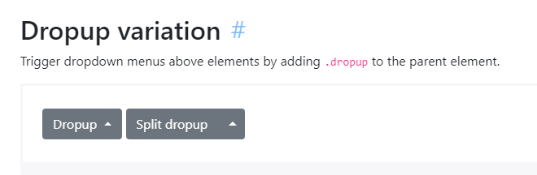

**CODE:**

<!-- Default dropup button -->

<div class="btn-group dropup">

<button type="button" class="btn btn-secondary dropdown-toggle" data-toggle="dropdown" aria-haspopup="true" aria-expanded="false">

Dropup

</button>

<div class="dropdown-menu">

<!-- Dropdown menu links -->

</div>

</div>

<!-- Split dropup button -->

<div class="btn-group dropup">

<button type="button" class="btn btn-secondary">

Split dropup

</button>

<button type="button" class="btn btn-secondary dropdown-toggle dropdown-toggle-split" data-toggle="dropdown" aria-haspopup="true" aria-expanded="false">

<span class="sr-only">Toggle Dropdown</span>

</button>

<div class="dropdown-menu">

<!-- Dropdown menu links -->

</div>

</div>

**CODE:**

<!-- Default dropright button -->

<div class="btn-group dropright">

<button type="button" class="btn btn-secondary dropdown-toggle" data-toggle="dropdown" aria-haspopup="true" aria-expanded="false">

Dropright

</button>

<div class="dropdown-menu">

<!-- Dropdown menu links -->

</div>

</div>

<!-- Split dropright button -->

<div class="btn-group dropright">

<button type="button" class="btn btn-secondary">

Split dropright

</button>

<button type="button" class="btn btn-secondary dropdown-toggle dropdown-toggle-split" data-toggle="dropdown" aria-haspopup="true" aria-expanded="false">

<span class="sr-only">Toggle Dropright</span>

</button>

<div class="dropdown-menu">

<!-- Dropdown menu links -->

</div>

</div>

**CODE:**

<!-- Default dropleft button -->

<div class="btn-group dropleft">

<button type="button" class="btn btn-secondary dropdown-toggle" data-toggle="dropdown" aria-haspopup="true" aria-expanded="false">

Dropleft

</button>

<div class="dropdown-menu">

<!-- Dropdown menu links -->

</div>

</div>

<!-- Split dropleft button -->

<div class="btn-group">

<div class="btn-group dropleft" role="group">

<button type="button" class="btn btn-secondary dropdown-toggle dropdown-toggle-split" data-toggle="dropdown" aria-haspopup="true" aria-expanded="false">

<span class="sr-only">Toggle Dropleft</span>

</button>

<div class="dropdown-menu">

<!-- Dropdown menu links -->

</div>

</div>

<button type="button" class="btn btn-secondary">

Split dropleft

</button>

</div>

**CODE:**

<div class="dropdown">

<button class="btn btn-secondary dropdown-toggle" type="button" id="dropdownMenu2" data-toggle="dropdown" aria-haspopup="true" aria-expanded="false">

Dropdown

</button>

<div class="dropdown-menu" aria-labelledby="dropdownMenu2">

<button class="dropdown-item" type="button">Action</button>

<button class="dropdown-item" type="button">Another action</button>

<button class="dropdown-item" type="button">Something else here</button>

</div>

</div>

**CODE:**

<div class="btn-group">

<button type="button" class="btn btn-secondary dropdown-toggle" data-toggle="dropdown" aria-haspopup="true" aria-expanded="false">

Right-aligned menu

</button>

<div class="dropdown-menu dropdown-menu-right">

<button class="dropdown-item" type="button">Action</button>

<button class="dropdown-item" type="button">Another action</button>

<button class="dropdown-item" type="button">Something else here</button>

</div>

</div>

**CODE:**

<div class="dropdown-menu">

<h6 class="dropdown-header">Dropdown header</h6>

<a class="dropdown-item" href="#">Action</a>

<a class="dropdown-item" href="#">Another action</a>

</div>

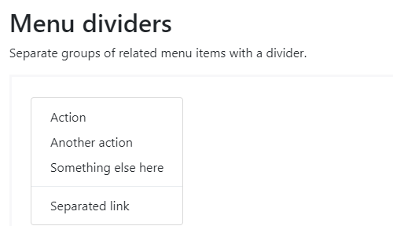

**CODE:**

<div class="dropdown-menu">

<a class="dropdown-item" href="#">Action</a>

<a class="dropdown-item" href="#">Another action</a>

<a class="dropdown-item" href="#">Something else here</a>

<div class="dropdown-divider"></div>

<a class="dropdown-item" href="#">Separated link</a>

</div>

**CODE:**

<div class="dropdown-menu">

<form class="px-4 py-3">

<div class="form-group">

<label for="exampleDropdownFormEmail1">Email address</label>

<input type="email" class="form-control" id="exampleDropdownFormEmail1" placeholder="email@example.com">

</div>

<div class="form-group">

<label for="exampleDropdownFormPassword1">Password</label>

<input type="password" class="form-control" id="exampleDropdownFormPassword1" placeholder="Password">

</div>

<div class="form-check">

<input type="checkbox" class="form-check-input" id="dropdownCheck">

<label class="form-check-label" for="dropdownCheck">

Remember me

</label>

</div>

<button type="submit" class="btn btn-primary">Sign in</button>

</form>

<div class="dropdown-divider"></div>

<a class="dropdown-item" href="#">New around here? Sign up</a>

<a class="dropdown-item" href="#">Forgot password?</a>

</div>

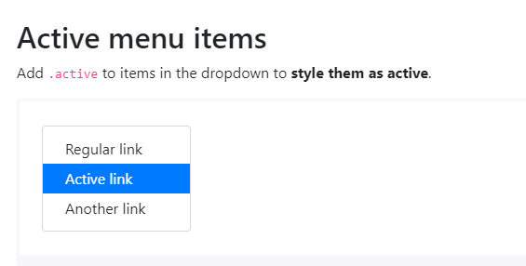

**CODE:**

<div class="dropdown-menu">

<a class="dropdown-item" href="#">Regular link</a>

<a class="dropdown-item active" href="#">Active link</a>

<a class="dropdown-item" href="#">Another link</a>

</div>

**CODE:**

<div class="dropdown-menu">

<a class="dropdown-item" href="#">Regular link</a>

<a class="dropdown-item disabled" href="#">Disabled link</a>

<a class="dropdown-item" href="#">Another link</a>

</div>

**FORMS**

**CODE:**

<form>

<div class="form-group">

<label for="exampleInputEmail1">Email address</label>

<input type="email" class="form-control" id="exampleInputEmail1" aria-describedby="emailHelp" placeholder="Enter email">

<small id="emailHelp" class="form-text text-muted">We'll never share your email with anyone else.</small>

</div>

<div class="form-group">

<label for="exampleInputPassword1">Password</label>

<input type="password" class="form-control" id="exampleInputPassword1" placeholder="Password">

</div>

<div class="form-check">

<input type="checkbox" class="form-check-input" id="exampleCheck1">

<label class="form-check-label" for="exampleCheck1">Check me out</label>

</div>

<button type="submit" class="btn btn-primary">Submit</button>

</form>

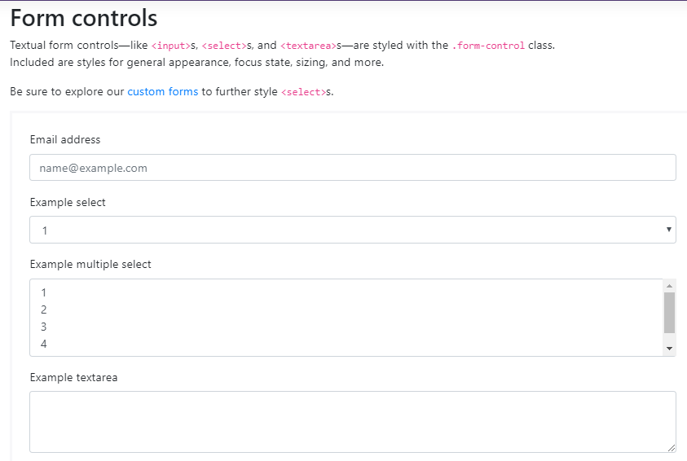

**CODE:**

<form>

<div class="form-group">

<label for="exampleFormControlInput1">Email address</label>

<input type="email" class="form-control" id="exampleFormControlInput1" placeholder="name@example.com">

</div>

<div class="form-group">

<label for="exampleFormControlSelect1">Example select</label>

<select class="form-control" id="exampleFormControlSelect1">

<option>1</option>

<option>2</option>

<option>3</option>

<option>4</option>

<option>5</option>

</select>

</div>

<div class="form-group">

<label for="exampleFormControlSelect2">Example multiple select</label>

<select multiple class="form-control" id="exampleFormControlSelect2">

<option>1</option>

<option>2</option>

<option>3</option>

<option>4</option>

<option>5</option>

</select>

</div>

<div class="form-group">

<label for="exampleFormControlTextarea1">Example textarea</label>

<textarea class="form-control" id="exampleFormControlTextarea1" rows="3"></textarea>

</div>

</form>

**CODE:**

<form>

<div class="form-group">

<label for="exampleFormControlFile1">Example file input</label>

<input type="file" class="form-control-file" id="exampleFormControlFile1">

</div>

</form>

**CODE:**

<input class="form-control form-control-lg" type="text" placeholder=".form-control-lg">

<input class="form-control" type="text" placeholder="Default input">

<input class="form-control form-control-sm" type="text" placeholder=".form-control-sm">

**CODE:**

<select class="form-control form-control-lg">

<option>Large select</option>

</select>

<select class="form-control">

<option>Default select</option>

</select>

<select class="form-control form-control-sm">

<option>Small select</option>

</select>

**CODE:**

<input class="form-control" type="text" placeholder="Readonly input here…" readonly>

**CODE:**

<form>

<div class="form-group row">

<label for="staticEmail" class="col-sm-2 col-form-label">Email</label>

<div class="col-sm-10">

<input type="text" readonly class="form-control-plaintext" id="staticEmail" value="email@example.com">

</div>

</div>

<div class="form-group row">

<label for="inputPassword" class="col-sm-2 col-form-label">Password</label>

<div class="col-sm-10">

<input type="password" class="form-control" id="inputPassword" placeholder="Password">

</div>

</div>

</form>

**CODE:**

<form class="form-inline">

<div class="form-group mb-2">

<label for="staticEmail2" class="sr-only">Email</label>

<input type="text" readonly class="form-control-plaintext" id="staticEmail2" value="email@example.com">

</div>

<div class="form-group mx-sm-3 mb-2">

<label for="inputPassword2" class="sr-only">Password</label>

<input type="password" class="form-control" id="inputPassword2" placeholder="Password">

</div>

<button type="submit" class="btn btn-primary mb-2">Confirm identity</button>

</form>

Checkboxes and radios



**CODE:**

<div class="form-check">

<input class="form-check-input" type="checkbox" value="" id="defaultCheck1">

<label class="form-check-label" for="defaultCheck1">

Default checkbox

</label>

</div>

<div class="form-check">

<input class="form-check-input" type="checkbox" value="" id="defaultCheck2" disabled>

<label class="form-check-label" for="defaultCheck2">

Disabled checkbox

</label>

</div>

**RADIOS**

**CODE:**

<div class="form-check">

<input class="form-check-input" type="radio" name="exampleRadios" id="exampleRadios1" value="option1" checked>

<label class="form-check-label" for="exampleRadios1">

Default radio

</label>

</div>

<div class="form-check">

<input class="form-check-input" type="radio" name="exampleRadios" id="exampleRadios2" value="option2">

<label class="form-check-label" for="exampleRadios2">

Second default radio

</label>

</div>

<div class="form-check disabled">

<input class="form-check-input" type="radio" name="exampleRadios" id="exampleRadios3" value="option3" disabled>

<label class="form-check-label" for="exampleRadios3">

Disabled radio

</label>

</div>

**CODE:**

<div class="form-check form-check-inline">

<input class="form-check-input" type="checkbox" id="inlineCheckbox1" value="option1">

<label class="form-check-label" for="inlineCheckbox1">1</label>

</div>

<div class="form-check form-check-inline">

<input class="form-check-input" type="checkbox" id="inlineCheckbox2" value="option2">

<label class="form-check-label" for="inlineCheckbox2">2</label>

</div>

<div class="form-check form-check-inline">

<input class="form-check-input" type="checkbox" id="inlineCheckbox3" value="option3" disabled>

<label class="form-check-label" for="inlineCheckbox3">3 (disabled)</label>

</div>



**CODE:**

<div class="form-check form-check-inline">

<input class="form-check-input" type="radio" name="inlineRadioOptions" id="inlineRadio1" value="option1">

<label class="form-check-label" for="inlineRadio1">1</label>

</div>

<div class="form-check form-check-inline">

<input class="form-check-input" type="radio" name="inlineRadioOptions" id="inlineRadio2" value="option2">

<label class="form-check-label" for="inlineRadio2">2</label>

</div>

<div class="form-check form-check-inline">

<input class="form-check-input" type="radio" name="inlineRadioOptions" id="inlineRadio3" value="option3" disabled>

<label class="form-check-label" for="inlineRadio3">3 (disabled)</label>

</div>

**CODE:**

<div class="form-check">

<input class="form-check-input position-static" type="checkbox" id="blankCheckbox" value="option1" aria-label="...">

</div>

<div class="form-check">

<input class="form-check-input position-static" type="radio" name="blankRadio" id="blankRadio1" value="option1" aria-label="...">

</div>

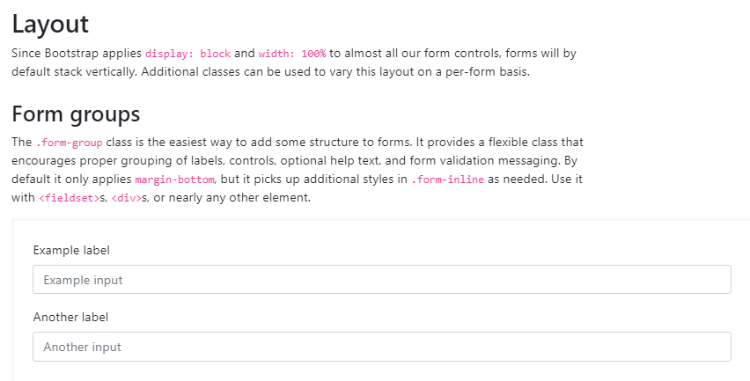

**CODE:**

<form>

<div class="form-group">

<label for="formGroupExampleInput">Example label</label>

<input type="text" class="form-control" id="formGroupExampleInput" placeholder="Example input">

</div>

<div class="form-group">

<label for="formGroupExampleInput2">Another label</label>

<input type="text" class="form-control" id="formGroupExampleInput2" placeholder="Another input">

</div>

</form>

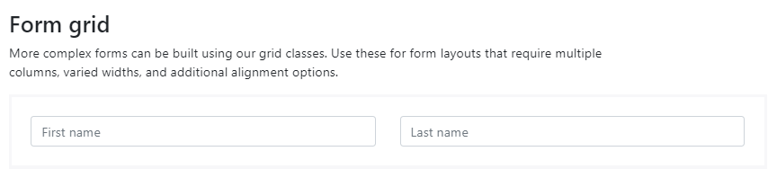

**CODE:**

<form>

<div class="row">

<div class="col">

<input type="text" class="form-control" placeholder="First name">

</div>

<div class="col">

<input type="text" class="form-control" placeholder="Last name">

</div>

</div>

</form>

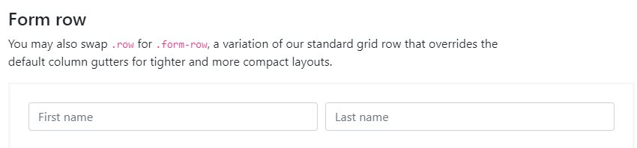

**CODE:**

<form>

<div class="form-row">

<div class="col">

<input type="text" class="form-control" placeholder="First name">

</div>

<div class="col">

<input type="text" class="form-control" placeholder="Last name">

</div>

</div>

</form>

**CODE:**

<form>

<div class="form-row">

<div class="form-group col-md-6">

<label for="inputEmail4">Email</label>

<input type="email" class="form-control" id="inputEmail4" placeholder="Email">

</div>

<div class="form-group col-md-6">

<label for="inputPassword4">Password</label>

<input type="password" class="form-control" id="inputPassword4" placeholder="Password">

</div>

</div>

<div class="form-group">

<label for="inputAddress">Address</label>

<input type="text" class="form-control" id="inputAddress" placeholder="1234 Main St">

</div>

<div class="form-group">

<label for="inputAddress2">Address 2</label>

<input type="text" class="form-control" id="inputAddress2" placeholder="Apartment, studio, or floor">

</div>

<div class="form-row">

<div class="form-group col-md-6">

<label for="inputCity">City</label>

<input type="text" class="form-control" id="inputCity">

</div>

<div class="form-group col-md-4">

<label for="inputState">State</label>

<select id="inputState" class="form-control">

<option selected>Choose...</option>

<option>...</option>

</select>

</div>

<div class="form-group col-md-2">

<label for="inputZip">Zip</label>

<input type="text" class="form-control" id="inputZip">

</div>

</div>

<div class="form-group">

<div class="form-check">

<input class="form-check-input" type="checkbox" id="gridCheck">

<label class="form-check-label" for="gridCheck">

Check me out

</label>

</div>

</div>

<button type="submit" class="btn btn-primary">Sign in</button>

</form>

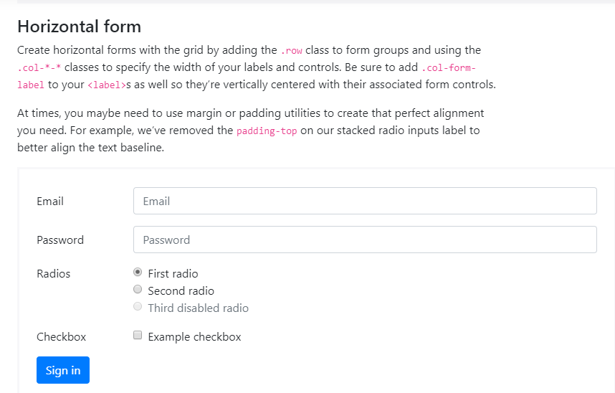

**CODE:**

<form>

<div class="form-group row">

<label for="inputEmail3" class="col-sm-2 col-form-label">Email</label>

<div class="col-sm-10">

<input type="email" class="form-control" id="inputEmail3" placeholder="Email">

</div>

</div>

<div class="form-group row">

<label for="inputPassword3" class="col-sm-2 col-form-label">Password</label>

<div class="col-sm-10">

<input type="password" class="form-control" id="inputPassword3" placeholder="Password">

</div>

</div>

<fieldset class="form-group">

<div class="row">

<legend class="col-form-label col-sm-2 pt-0">Radios</legend>

<div class="col-sm-10">

<div class="form-check">

<input class="form-check-input" type="radio" name="gridRadios" id="gridRadios1" value="option1" checked>

<label class="form-check-label" for="gridRadios1">

First radio

</label>

</div>

<div class="form-check">

<input class="form-check-input" type="radio" name="gridRadios" id="gridRadios2" value="option2">

<label class="form-check-label" for="gridRadios2">

Second radio

</label>

</div>

<div class="form-check disabled">

<input class="form-check-input" type="radio" name="gridRadios" id="gridRadios3" value="option3" disabled>

<label class="form-check-label" for="gridRadios3">

Third disabled radio

</label>

</div>

</div>

</div>

</fieldset>

<div class="form-group row">

<div class="col-sm-2">Checkbox</div>

<div class="col-sm-10">

<div class="form-check">

<input class="form-check-input" type="checkbox" id="gridCheck1">

<label class="form-check-label" for="gridCheck1">

Example checkbox

</label>

</div>

</div>

</div>

<div class="form-group row">

<div class="col-sm-10">

<button type="submit" class="btn btn-primary">Sign in</button>

</div>

</div>

</form>

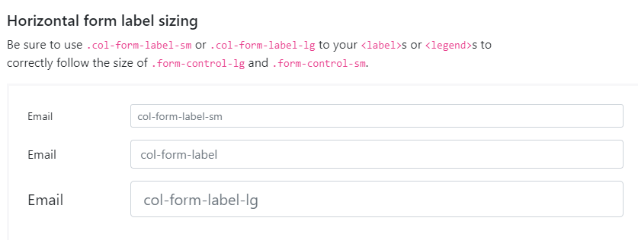

**CODE:**

<form>

<div class="form-group row">

<label for="colFormLabelSm" class="col-sm-2 col-form-label col-form-label-sm">Email</label>

<div class="col-sm-10">

<input type="email" class="form-control form-control-sm" id="colFormLabelSm" placeholder="col-form-label-sm">

</div>

</div>

<div class="form-group row">

<label for="colFormLabel" class="col-sm-2 col-form-label">Email</label>

<div class="col-sm-10">

<input type="email" class="form-control" id="colFormLabel" placeholder="col-form-label">

</div>

</div>

<div class="form-group row">

<label for="colFormLabelLg" class="col-sm-2 col-form-label col-form-label-lg">Email</label>

<div class="col-sm-10">

<input type="email" class="form-control form-control-lg" id="colFormLabelLg" placeholder="col-form-label-lg">

</div>

</div>

</form>

**CODE:**

<form>

<div class="form-row">

<div class="col-7">

<input type="text" class="form-control" placeholder="City">

</div>

<div class="col">

<input type="text" class="form-control" placeholder="State">

</div>

<div class="col">

<input type="text" class="form-control" placeholder="Zip">

</div>

</div>

</form>

**CODE:**

<form>

<div class="form-row align-items-center">

<div class="col-auto">

<label class="sr-only" for="inlineFormInput">Name</label>

<input type="text" class="form-control mb-2" id="inlineFormInput" placeholder="Jane Doe">

</div>

<div class="col-auto">

<label class="sr-only" for="inlineFormInputGroup">Username</label>

<div class="input-group mb-2">

<div class="input-group-prepend">

<div class="input-group-text">@</div>

</div>

<input type="text" class="form-control" id="inlineFormInputGroup" placeholder="Username">

</div>

</div>

<div class="col-auto">

<div class="form-check mb-2">

<input class="form-check-input" type="checkbox" id="autoSizingCheck">

<label class="form-check-label" for="autoSizingCheck">

Remember me

</label>

</div>

</div>

<div class="col-auto">

<button type="submit" class="btn btn-primary mb-2">Submit</button>

</div>

</div>

</form>

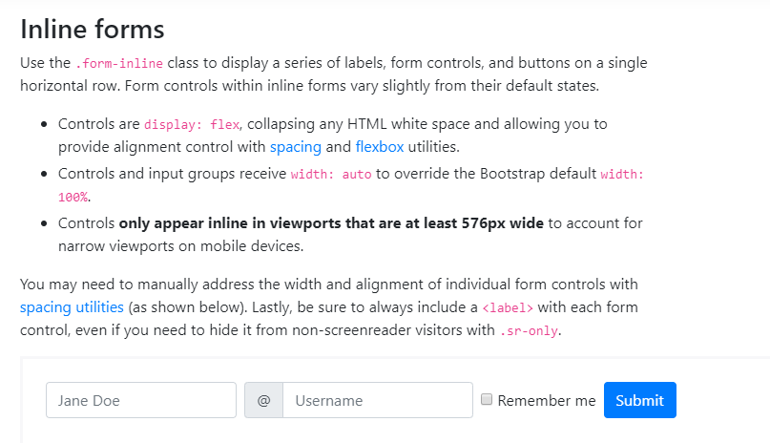

**CODE:**

<form class="form-inline">

<label class="sr-only" for="inlineFormInputName2">Name</label>

<input type="text" class="form-control mb-2 mr-sm-2" id="inlineFormInputName2" placeholder="Jane Doe">

<label class="sr-only" for="inlineFormInputGroupUsername2">Username</label>

<div class="input-group mb-2 mr-sm-2">

<div class="input-group-prepend">

<div class="input-group-text">@</div>

</div>

<input type="text" class="form-control" id="inlineFormInputGroupUsername2" placeholder="Username">

</div>

<div class="form-check mb-2 mr-sm-2">

<input class="form-check-input" type="checkbox" id="inlineFormCheck">

<label class="form-check-label" for="inlineFormCheck">

Remember me

</label>

</div>

<button type="submit" class="btn btn-primary mb-2">Submit</button>

</form>

**CODE:**

<form class="form-inline">

<label class="my-1 mr-2" for="inlineFormCustomSelectPref">Preference</label>

<select class="custom-select my-1 mr-sm-2" id="inlineFormCustomSelectPref">

<option selected>Choose...</option>

<option value="1">One</option>

<option value="2">Two</option>

<option value="3">Three</option>

</select>

<div class="custom-control custom-checkbox my-1 mr-sm-2">

<input type="checkbox" class="custom-control-input" id="customControlInline">

<label class="custom-control-label" for="customControlInline">Remember my preference</label>

</div>

<button type="submit" class="btn btn-primary my-1">Submit</button>

</form>

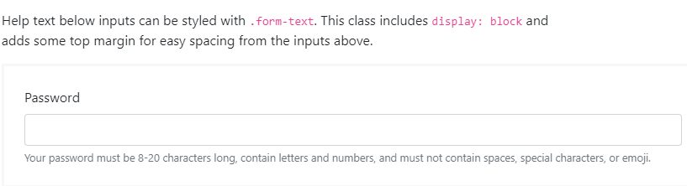

**CODE:**

<label for="inputPassword5">Password</label>

<input type="password" id="inputPassword5" class="form-control" aria-describedby="passwordHelpBlock">

<small id="passwordHelpBlock" class="form-text text-muted">

Your password must be 8-20 characters long, contain letters and numbers, and must not contain spaces, special characters, or emoji.

</small>

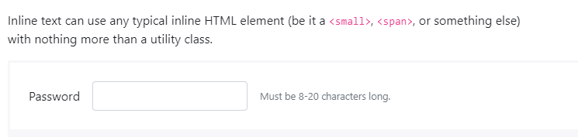

**CODE:**

<form class="form-inline">

<div class="form-group">

<label for="inputPassword6">Password</label>

<input type="password" id="inputPassword6" class="form-control mx-sm-3" aria-describedby="passwordHelpInline">

<small id="passwordHelpInline" class="text-muted">

Must be 8-20 characters long.

</small>

</div>

</form>

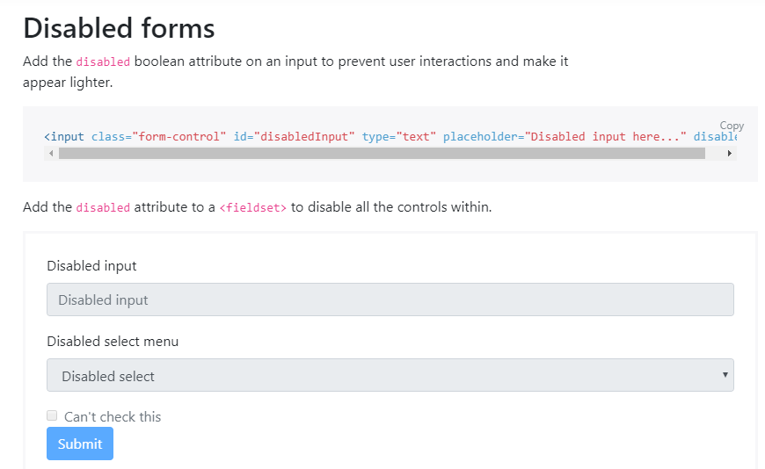

**CODE:**

<form>

<fieldset disabled>

<div class="form-group">

<label for="disabledTextInput">Disabled input</label>

<input type="text" id="disabledTextInput" class="form-control" placeholder="Disabled input">

</div>

<div class="form-group">

<label for="disabledSelect">Disabled select menu</label>

<select id="disabledSelect" class="form-control">

<option>Disabled select</option>

</select>

</div>

<div class="form-check">

<input class="form-check-input" type="checkbox" id="disabledFieldsetCheck" disabled>

<label class="form-check-label" for="disabledFieldsetCheck">

Can't check this

</label>

</div>

<button type="submit" class="btn btn-primary">Submit</button>

</fieldset>

</form>

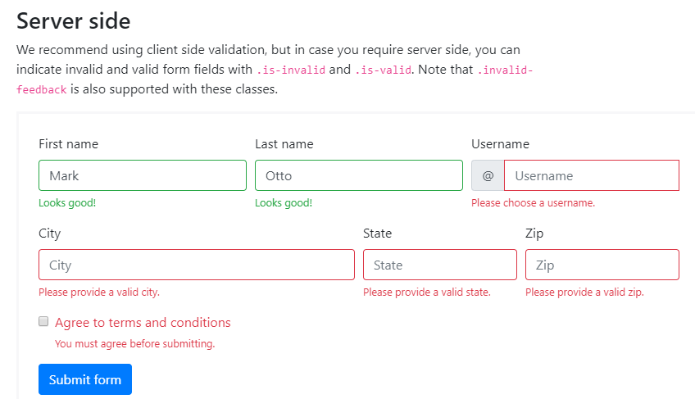

**CODE:**

<form>

<div class="form-row">

<div class="col-md-4 mb-3">

<label for="validationServer01">First name</label>

<input type="text" class="form-control is-valid" id="validationServer01" placeholder="First name" value="Mark" required>

<div class="valid-feedback">

Looks good!

</div>

</div>

<div class="col-md-4 mb-3">

<label for="validationServer02">Last name</label>

<input type="text" class="form-control is-valid" id="validationServer02" placeholder="Last name" value="Otto" required>

<div class="valid-feedback">

Looks good!

</div>

</div>

<div class="col-md-4 mb-3">

<label for="validationServerUsername">Username</label>

<div class="input-group">

<div class="input-group-prepend">

<span class="input-group-text" id="inputGroupPrepend3">@</span>

</div>

<input type="text" class="form-control is-invalid" id="validationServerUsername" placeholder="Username" aria-describedby="inputGroupPrepend3" required>

<div class="invalid-feedback">

Please choose a username.

</div>

</div>

</div>

</div>

<div class="form-row">

<div class="col-md-6 mb-3">

<label for="validationServer03">City</label>

<input type="text" class="form-control is-invalid" id="validationServer03" placeholder="City" required>

<div class="invalid-feedback">

Please provide a valid city.

</div>

</div>

<div class="col-md-3 mb-3">

<label for="validationServer04">State</label>

<input type="text" class="form-control is-invalid" id="validationServer04" placeholder="State" required>

<div class="invalid-feedback">

Please provide a valid state.

</div>

</div>

<div class="col-md-3 mb-3">

<label for="validationServer05">Zip</label>

<input type="text" class="form-control is-invalid" id="validationServer05" placeholder="Zip" required>

<div class="invalid-feedback">

Please provide a valid zip.

</div>

</div>

</div>

<div class="form-group">

<div class="form-check">

<input class="form-check-input is-invalid" type="checkbox" value="" id="invalidCheck3" required>

<label class="form-check-label" for="invalidCheck3">

Agree to terms and conditions

</label>

<div class="invalid-feedback">

You must agree before submitting.

</div>

</div>

</div>

<button class="btn btn-primary" type="submit">Submit form</button>

</form>

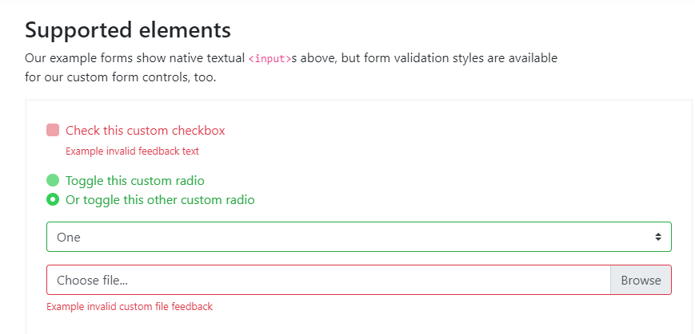

**CODE:**

<form class="was-validated">

<div class="custom-control custom-checkbox mb-3">

<input type="checkbox" class="custom-control-input" id="customControlValidation1" required>

<label class="custom-control-label" for="customControlValidation1">Check this custom checkbox</label>

<div class="invalid-feedback">Example invalid feedback text</div>

</div>

<div class="custom-control custom-radio">

<input type="radio" class="custom-control-input" id="customControlValidation2" name="radio-stacked" required>

<label class="custom-control-label" for="customControlValidation2">Toggle this custom radio</label>

</div>

<div class="custom-control custom-radio mb-3">

<input type="radio" class="custom-control-input" id="customControlValidation3" name="radio-stacked" required>

<label class="custom-control-label" for="customControlValidation3">Or toggle this other custom radio</label>

<div class="invalid-feedback">More example invalid feedback text</div>

</div>

<div class="form-group">

<select class="custom-select" required>

<option value="">Open this select menu</option>

<option value="1">One</option>

<option value="2">Two</option>

<option value="3">Three</option>

</select>

<div class="invalid-feedback">Example invalid custom select feedback</div>

</div>

<div class="custom-file">

<input type="file" class="custom-file-input" id="validatedCustomFile" required>

<label class="custom-file-label" for="validatedCustomFile">Choose file...</label>

<div class="invalid-feedback">Example invalid custom file feedback</div>

</div>

</form>



**CODE:**

<div class="custom-control custom-checkbox">

<input type="checkbox" class="custom-control-input" id="customCheck1">

<label class="custom-control-label" for="customCheck1">Check this custom checkbox</label>

</div>

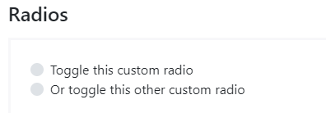

**CODE:**

<div class="custom-control custom-radio">

<input type="radio" id="customRadio1" name="customRadio" class="custom-control-input">

<label class="custom-control-label" for="customRadio1">Toggle this custom radio</label>

</div>

<div class="custom-control custom-radio">

<input type="radio" id="customRadio2" name="customRadio" class="custom-control-input">

<label class="custom-control-label" for="customRadio2">Or toggle this other custom radio</label>

</div>

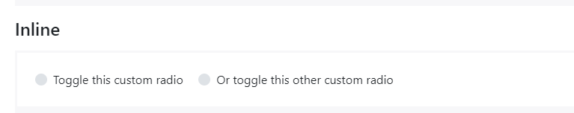

**CODE:**

<div class="custom-control custom-radio custom-control-inline">

<input type="radio" id="customRadioInline1" name="customRadioInline1" class="custom-control-input">

<label class="custom-control-label" for="customRadioInline1">Toggle this custom radio</label>

</div>

<div class="custom-control custom-radio custom-control-inline">

<input type="radio" id="customRadioInline2" name="customRadioInline1" class="custom-control-input">

<label class="custom-control-label" for="customRadioInline2">Or toggle this other custom radio</label>

</div>

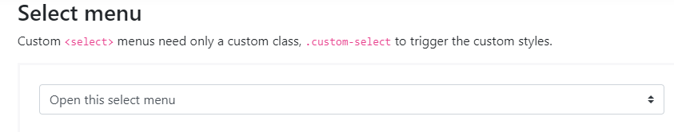

**CODE:**

<select class="custom-select">

<option selected>Open this select menu</option>

<option value="1">One</option>

<option value="2">Two</option>

<option value="3">Three</option>

</select>

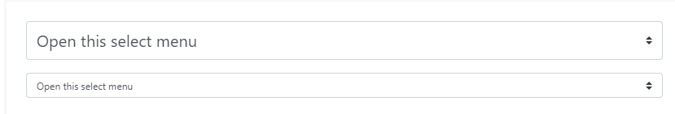

**CODE:**

<select class="custom-select custom-select-lg mb-3">

<option selected>Open this select menu</option>

<option value="1">One</option>

<option value="2">Two</option>

<option value="3">Three</option>

</select>

<select class="custom-select custom-select-sm">

<option selected>Open this select menu</option>

<option value="1">One</option>

<option value="2">Two</option>

<option value="3">Three</option>

</select>

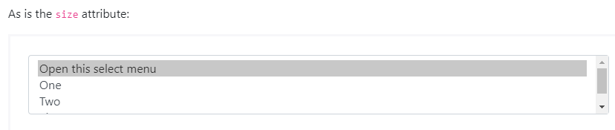

CODE:

<select class="custom-select" size="3">

<option selected>Open this select menu</option>

<option value="1">One</option>

<option value="2">Two</option>

<option value="3">Three</option>

</select>

**INPUT GROUPS**

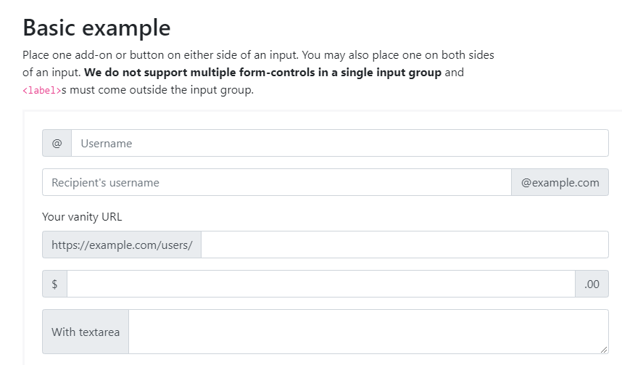

**CODE:**

<div class="input-group mb-3">

<div class="input-group-prepend">

<span class="input-group-text" id="basic-addon1">@</span>

</div>

<input type="text" class="form-control" placeholder="Username" aria-label="Username" aria-describedby="basic-addon1">

</div>

<div class="input-group mb-3">

<input type="text" class="form-control" placeholder="Recipient's username" aria-label="Recipient's username" aria-describedby="basic-addon2">

<div class="input-group-append">

<span class="input-group-text" id="basic-addon2">@example.com</span>

</div>

</div>

<label for="basic-url">Your vanity URL</label>

<div class="input-group mb-3">

<div class="input-group-prepend">

<span class="input-group-text" id="basic-addon3">https://example.com/users/</span>

</div>

<input type="text" class="form-control" id="basic-url" aria-describedby="basic-addon3">

</div>

<div class="input-group mb-3">

<div class="input-group-prepend">

<span class="input-group-text">$</span>

</div>

<input type="text" class="form-control" aria-label="Amount (to the nearest dollar)">

<div class="input-group-append">

<span class="input-group-text">.00</span>

</div>

</div>

<div class="input-group">

<div class="input-group-prepend">

<span class="input-group-text">With textarea</span>

</div>

<textarea class="form-control" aria-label="With textarea"></textarea>

</div>

**CODE:**

<div class="input-group input-group-sm mb-3">

<div class="input-group-prepend">

<span class="input-group-text" id="inputGroup-sizing-sm">Small</span>

</div>

<input type="text" class="form-control" aria-label="Small" aria-describedby="inputGroup-sizing-sm">

</div>

<div class="input-group mb-3">

<div class="input-group-prepend">

<span class="input-group-text" id="inputGroup-sizing-default">Default</span>

</div>

<input type="text" class="form-control" aria-label="Default" aria-describedby="inputGroup-sizing-default">

</div>

<div class="input-group input-group-lg">

<div class="input-group-prepend">

<span class="input-group-text" id="inputGroup-sizing-lg">Large</span>

</div>

<input type="text" class="form-control" aria-label="Large" aria-describedby="inputGroup-sizing-sm">

</div>

**CODE:**

<div class="input-group mb-3">

<div class="input-group-prepend">

<div class="input-group-text">

<input type="checkbox" aria-label="Checkbox for following text input">

</div>

</div>

<input type="text" class="form-control" aria-label="Text input with checkbox">

</div>

<div class="input-group">

<div class="input-group-prepend">

<div class="input-group-text">

<input type="radio" aria-label="Radio button for following text input">

</div>

</div>

<input type="text" class="form-control" aria-label="Text input with radio button">

</div>

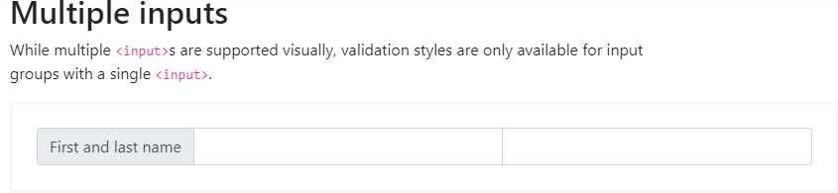

**CODE:**

<div class="input-group">

<div class="input-group-prepend">

<span class="input-group-text" id="">First and last name</span>

</div>

<input type="text" class="form-control">

<input type="text" class="form-control">

</div>

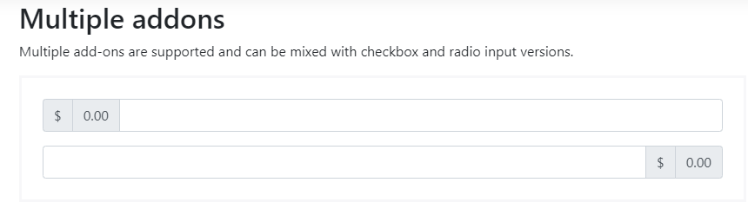

**CODE:**

<div class="input-group mb-3">

<div class="input-group-prepend">

<span class="input-group-text">$</span>

<span class="input-group-text">0.00</span>

</div>

<input type="text" class="form-control" aria-label="Amount (to the nearest dollar)">

</div>

<div class="input-group">

<input type="text" class="form-control" aria-label="Amount (to the nearest dollar)">

<div class="input-group-append">

<span class="input-group-text">$</span>

<span class="input-group-text">0.00</span>

</div>

</div>

**CODE:**

<div class="input-group mb-3">

<div class="input-group-prepend">

<button class="btn btn-outline-secondary" type="button">Button</button>

</div>

<input type="text" class="form-control" placeholder="" aria-label="" aria-describedby="basic-addon1">

</div>

<div class="input-group mb-3">

<input type="text" class="form-control" placeholder="Recipient's username" aria-label="Recipient's username" aria-describedby="basic-addon2">

<div class="input-group-append">

<button class="btn btn-outline-secondary" type="button">Button</button>

</div>

</div>

<div class="input-group mb-3">

<div class="input-group-prepend">

<button class="btn btn-outline-secondary" type="button">Button</button>

<button class="btn btn-outline-secondary" type="button">Button</button>

</div>

<input type="text" class="form-control" placeholder="" aria-label="" aria-describedby="basic-addon1">

</div>

<div class="input-group">

<input type="text" class="form-control" placeholder="Recipient's username" aria-label="Recipient's username" aria-describedby="basic-addon2">

<div class="input-group-append">

<button class="btn btn-outline-secondary" type="button">Button</button>

<button class="btn btn-outline-secondary" type="button">Button</button>

</div>

</div>

**CODE:**

<div class="input-group mb-3">

<div class="input-group-prepend">

<button class="btn btn-outline-secondary dropdown-toggle" type="button" data-toggle="dropdown" aria-haspopup="true" aria-expanded="false">Dropdown</button>

<div class="dropdown-menu">

<a class="dropdown-item" href="#">Action</a>

<a class="dropdown-item" href="#">Another action</a>

<a class="dropdown-item" href="#">Something else here</a>

<div role="separator" class="dropdown-divider"></div>

<a class="dropdown-item" href="#">Separated link</a>

</div>

</div>

<input type="text" class="form-control" aria-label="Text input with dropdown button">

</div>

<div class="input-group">

<input type="text" class="form-control" aria-label="Text input with dropdown button">

<div class="input-group-append">

<button class="btn btn-outline-secondary dropdown-toggle" type="button" data-toggle="dropdown" aria-haspopup="true" aria-expanded="false">Dropdown</button>

<div class="dropdown-menu">

<a class="dropdown-item" href="#">Action</a>

<a class="dropdown-item" href="#">Another action</a>

<a class="dropdown-item" href="#">Something else here</a>

<div role="separator" class="dropdown-divider"></div>

<a class="dropdown-item" href="#">Separated link</a>

</div>

</div>

</div>

**CODE:**

<div class="input-group mb-3">

<div class="input-group-prepend">

<button type="button" class="btn btn-outline-secondary">Action</button>

<button type="button" class="btn btn-outline-secondary dropdown-toggle dropdown-toggle-split" data-toggle="dropdown" aria-haspopup="true" aria-expanded="false">

<span class="sr-only">Toggle Dropdown</span>

</button>

<div class="dropdown-menu">

<a class="dropdown-item" href="#">Action</a>

<a class="dropdown-item" href="#">Another action</a>

<a class="dropdown-item" href="#">Something else here</a>

<div role="separator" class="dropdown-divider"></div>

<a class="dropdown-item" href="#">Separated link</a>

</div>

</div>

<input type="text" class="form-control" aria-label="Text input with segmented dropdown button">

</div>

<div class="input-group">

<input type="text" class="form-control" aria-label="Text input with segmented dropdown button">

<div class="input-group-append">

<button type="button" class="btn btn-outline-secondary">Action</button>

<button type="button" class="btn btn-outline-secondary dropdown-toggle dropdown-toggle-split" data-toggle="dropdown" aria-haspopup="true" aria-expanded="false">

<span class="sr-only">Toggle Dropdown</span>

</button>

<div class="dropdown-menu">

<a class="dropdown-item" href="#">Action</a>

<a class="dropdown-item" href="#">Another action</a>

<a class="dropdown-item" href="#">Something else here</a>

<div role="separator" class="dropdown-divider"></div>

<a class="dropdown-item" href="#">Separated link</a>

</div>

</div>

</div>

**CODE:**

<div class="input-group mb-3">

<div class="input-group-prepend">

<label class="input-group-text" for="inputGroupSelect01">Options</label>

</div>

<select class="custom-select" id="inputGroupSelect01">

<option selected>Choose...</option>

<option value="1">One</option>

<option value="2">Two</option>

<option value="3">Three</option>

</select>

</div>

<div class="input-group mb-3">

<select class="custom-select" id="inputGroupSelect02">

<option selected>Choose...</option>

<option value="1">One</option>

<option value="2">Two</option>

<option value="3">Three</option>

</select>

<div class="input-group-append">

<label class="input-group-text" for="inputGroupSelect02">Options</label>

</div>

</div>

<div class="input-group mb-3">

<div class="input-group-prepend">

<button class="btn btn-outline-secondary" type="button">Button</button>

</div>

<select class="custom-select" id="inputGroupSelect03">

<option selected>Choose...</option>

<option value="1">One</option>

<option value="2">Two</option>

<option value="3">Three</option>

</select>

</div>

<div class="input-group">

<select class="custom-select" id="inputGroupSelect04">

<option selected>Choose...</option>

<option value="1">One</option>

<option value="2">Two</option>

<option value="3">Three</option>

</select>

<div class="input-group-append">

<button class="btn btn-outline-secondary" type="button">Button</button>

</div>

</div>

**CODE:**

<div class="input-group mb-3">

<div class="input-group-prepend">

<span class="input-group-text">Upload</span>

</div>

<div class="custom-file">

<input type="file" class="custom-file-input" id="inputGroupFile01">

<label class="custom-file-label" for="inputGroupFile01">Choose file</label>

</div>

</div>

<div class="input-group mb-3">

<div class="custom-file">

<input type="file" class="custom-file-input" id="inputGroupFile02">

<label class="custom-file-label" for="inputGroupFile02">Choose file</label>

</div>

<div class="input-group-append">

<span class="input-group-text" id="">Upload</span>

</div>

</div>

<div class="input-group mb-3">

<div class="input-group-prepend">

<button class="btn btn-outline-secondary" type="button">Button</button>

</div>

<div class="custom-file">

<input type="file" class="custom-file-input" id="inputGroupFile03">

<label class="custom-file-label" for="inputGroupFile03">Choose file</label>

</div>

</div>

<div class="input-group">

<div class="custom-file">

<input type="file" class="custom-file-input" id="inputGroupFile04">

<label class="custom-file-label" for="inputGroupFile04">Choose file</label>

</div>

<div class="input-group-append">

<button class="btn btn-outline-secondary" type="button">Button</button>

</div>

</div>

**JUMBOTRON**

Lightweight, flexible component for showcasing hero unit style content.

A lightweight, flexible component that can optionally extend the entire viewport to showcase key marketing messages on your site.

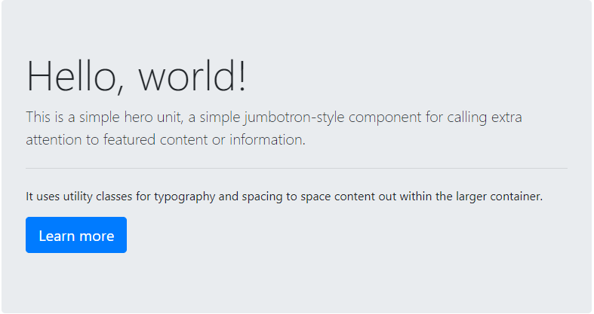

**CODE:**

<div class="jumbotron">

<h1 class="display-4">Hello, world!</h1>

<p class="lead">This is a simple hero unit, a simple jumbotron-style component for calling extra attention to featured content or information.</p>

<hr class="my-4">

<p>It uses utility classes for typography and spacing to space content out within the larger container.</p>

<p class="lead">

<a class="btn btn-primary btn-lg" href="#" role="button">Learn more</a>

</p>

</div>

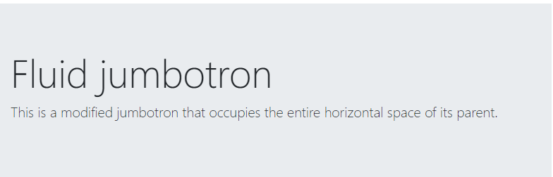

**CODE:**

<div class="jumbotron jumbotron-fluid">

<div class="container">

<h1 class="display-4">Fluid jumbotron</h1>

<p class="lead">This is a modified jumbotron that occupies the entire horizontal space of its parent.</p>

</div>

</div>

**LIST GROUP**

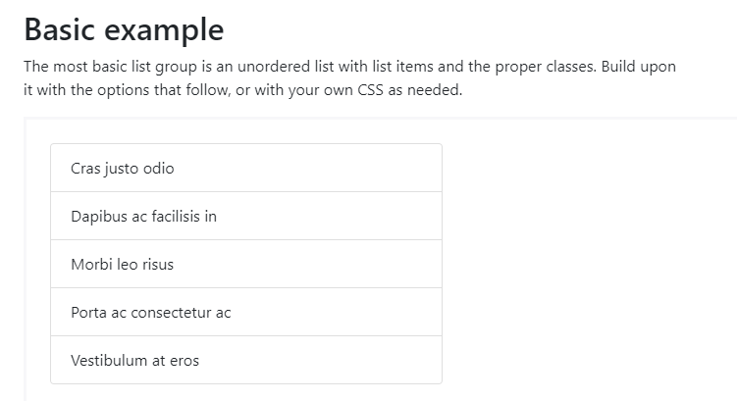

**CODE:**

<ul class="list-group">

<li class="list-group-item">Cras justo odio</li>

<li class="list-group-item">Dapibus ac facilisis in</li>

<li class="list-group-item">Morbi leo risus</li>

<li class="list-group-item">Porta ac consectetur ac</li>

<li class="list-group-item">Vestibulum at eros</li>

</ul>

**CODE:**

<ul class="list-group">

<li class="list-group-item active">Cras justo odio</li>

<li class="list-group-item">Dapibus ac facilisis in</li>

<li class="list-group-item">Morbi leo risus</li>

<li class="list-group-item">Porta ac consectetur ac</li>

<li class="list-group-item">Vestibulum at eros</li>

</ul>

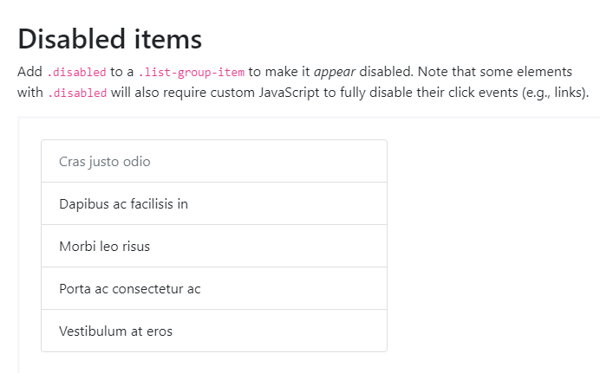

**CODE:**

<ul class="list-group">

<li class="list-group-item disabled">Cras justo odio</li>

<li class="list-group-item">Dapibus ac facilisis in</li>

<li class="list-group-item">Morbi leo risus</li>

<li class="list-group-item">Porta ac consectetur ac</li>

<li class="list-group-item">Vestibulum at eros</li>

</ul>

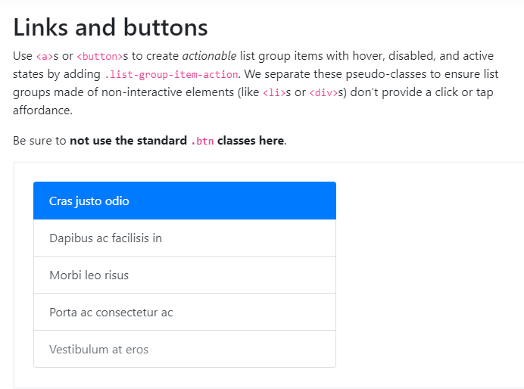

**CODE:**

<div class="list-group">

<a href="#" class="list-group-item list-group-item-action active">

Cras justo odio

</a>

<a href="#" class="list-group-item list-group-item-action">Dapibus ac facilisis in</a>

<a href="#" class="list-group-item list-group-item-action">Morbi leo risus</a>

<a href="#" class="list-group-item list-group-item-action">Porta ac consectetur ac</a>

<a href="#" class="list-group-item list-group-item-action disabled">Vestibulum at eros</a>

</div>

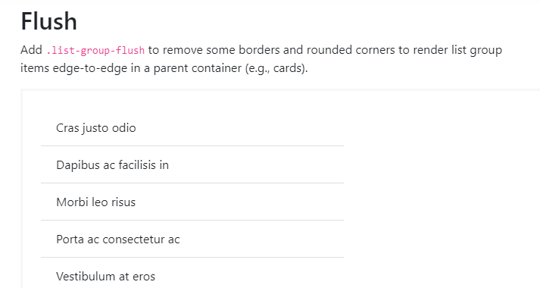

**CODE:**

<ul class="list-group list-group-flush">

<li class="list-group-item">Cras justo odio</li>

<li class="list-group-item">Dapibus ac facilisis in</li>

<li class="list-group-item">Morbi leo risus</li>

<li class="list-group-item">Porta ac consectetur ac</li>

<li class="list-group-item">Vestibulum at eros</li>

</ul>

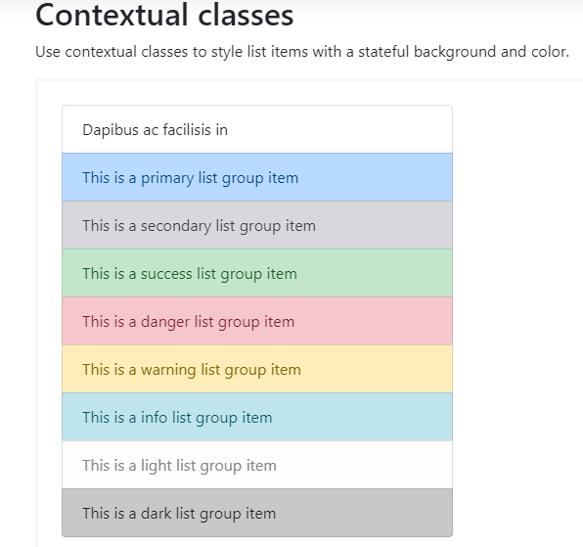

**CODE:**

<ul class="list-group">

<li class="list-group-item">Dapibus ac facilisis in</li>

<li class="list-group-item list-group-item-primary">This is a primary list group item</li>

<li class="list-group-item list-group-item-secondary">This is a secondary list group item</li>

<li class="list-group-item list-group-item-success">This is a success list group item</li>

<li class="list-group-item list-group-item-danger">This is a danger list group item</li>

<li class="list-group-item list-group-item-warning">This is a warning list group item</li>

<li class="list-group-item list-group-item-info">This is a info list group item</li>

<li class="list-group-item list-group-item-light">This is a light list group item</li>

<li class="list-group-item list-group-item-dark">This is a dark list group item</li>

</ul>

Contextual classes also work with .list-group-item-action. Note the addition of the hover styles here not present in the previous example. Also supported is the .active state; apply it to indicate an active selection on a contextual list group item.

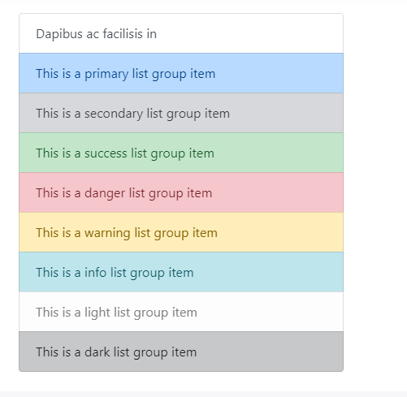

**CODE:**

<div class="list-group">

<a href="#" class="list-group-item list-group-item-action">Dapibus ac facilisis in</a>

<a href="#" class="list-group-item list-group-item-action list-group-item-primary">This is a primary list group item</a>

<a href="#" class="list-group-item list-group-item-action list-group-item-secondary">This is a secondary list group item</a>

<a href="#" class="list-group-item list-group-item-action list-group-item-success">This is a success list group item</a>

<a href="#" class="list-group-item list-group-item-action list-group-item-danger">This is a danger list group item</a>

<a href="#" class="list-group-item list-group-item-action list-group-item-warning">This is a warning list group item</a>

<a href="#" class="list-group-item list-group-item-action list-group-item-info">This is a info list group item</a>

<a href="#" class="list-group-item list-group-item-action list-group-item-light">This is a light list group item</a>

<a href="#" class="list-group-item list-group-item-action list-group-item-dark">This is a dark list group item</a>

</div>

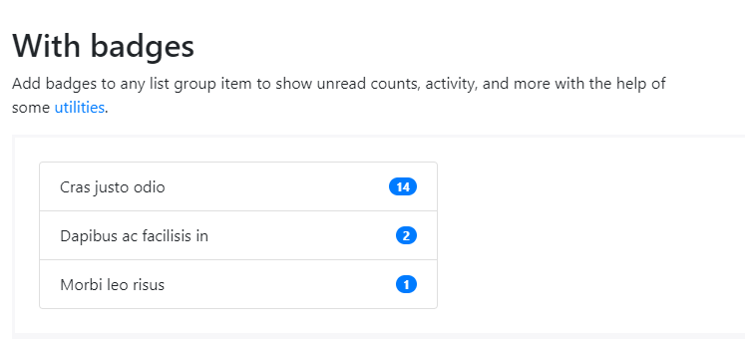

**CODE:**

<ul class="list-group">

<li class="list-group-item d-flex justify-content-between align-items-center">

Cras justo odio

<span class="badge badge-primary badge-pill">14</span>

</li>

<li class="list-group-item d-flex justify-content-between align-items-center">

Dapibus ac facilisis in

<span class="badge badge-primary badge-pill">2</span>

</li>

<li class="list-group-item d-flex justify-content-between align-items-center">

Morbi leo risus

<span class="badge badge-primary badge-pill">1</span>

</li>

</ul>

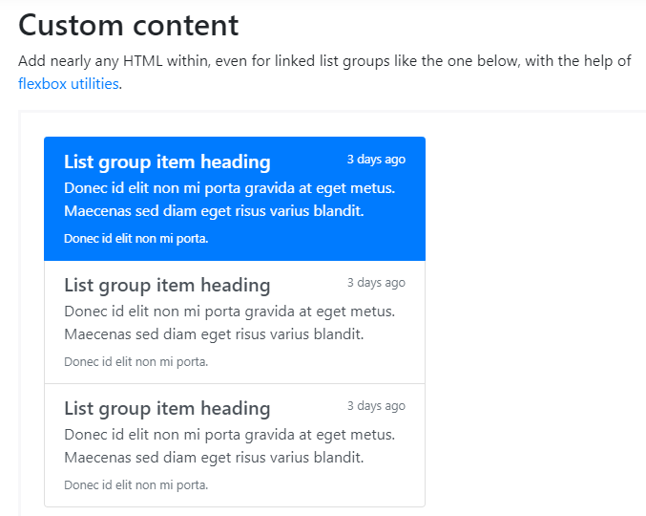

**CODE:**

<div class="list-group">

<a href="#" class="list-group-item list-group-item-action flex-column align-items-start active">

<div class="d-flex w-100 justify-content-between">

<h5 class="mb-1">List group item heading</h5>

<small>3 days ago</small>

</div>

<p class="mb-1">Donec id elit non mi porta gravida at eget metus. Maecenas sed diam eget risus varius blandit.</p>

<small>Donec id elit non mi porta.</small>

</a>

<a href="#" class="list-group-item list-group-item-action flex-column align-items-start">

<div class="d-flex w-100 justify-content-between">

<h5 class="mb-1">List group item heading</h5>

<small class="text-muted">3 days ago</small>

</div>

<p class="mb-1">Donec id elit non mi porta gravida at eget metus. Maecenas sed diam eget risus varius blandit.</p>

<small class="text-muted">Donec id elit non mi porta.</small>

</a>

<a href="#" class="list-group-item list-group-item-action flex-column align-items-start">

<div class="d-flex w-100 justify-content-between">

<h5 class="mb-1">List group item heading</h5>

<small class="text-muted">3 days ago</small>

</div>

<p class="mb-1">Donec id elit non mi porta gravida at eget metus. Maecenas sed diam eget risus varius blandit.</p>

<small class="text-muted">Donec id elit non mi porta.</small>

</a>

</div>

**CODE:**

<div class="row">

<div class="col-4">

<div class="list-group" id="list-tab" role="tablist">

<a class="list-group-item list-group-item-action active" id="list-home-list" data-toggle="list" href="#list-home" role="tab" aria-controls="home">Home</a>

<a class="list-group-item list-group-item-action" id="list-profile-list" data-toggle="list" href="#list-profile" role="tab" aria-controls="profile">Profile</a>

<a class="list-group-item list-group-item-action" id="list-messages-list" data-toggle="list" href="#list-messages" role="tab" aria-controls="messages">Messages</a>

<a class="list-group-item list-group-item-action" id="list-settings-list" data-toggle="list" href="#list-settings" role="tab" aria-controls="settings">Settings</a>

</div>

</div>

<div class="col-8">

<div class="tab-content" id="nav-tabContent">

<div class="tab-pane fade show active" id="list-home" role="tabpanel" aria-labelledby="list-home-list">...</div>

<div class="tab-pane fade" id="list-profile" role="tabpanel" aria-labelledby="list-profile-list">...</div>

<div class="tab-pane fade" id="list-messages" role="tabpanel" aria-labelledby="list-messages-list">...</div>

<div class="tab-pane fade" id="list-settings" role="tabpanel" aria-labelledby="list-settings-list">...</div>

</div>

</div>

</div>

**MODAL**

Use Bootstrap’s JavaScript modal plugin to add dialogs to your site for lightboxes, user notifications, or completely custom content.

## **How it works**

Before getting started with Bootstrap’s modal component, be sure to read the following as our menu options have recently changed.

* Modals are built with HTML, CSS, and JavaScript. They’re positioned over everything else in the document and remove scroll from the <body> so that modal content scrolls instead.
* Clicking on the modal “backdrop” will automatically close the modal.
* Bootstrap only supports one modal window at a time. Nested modals aren’t supported as we believe them to be poor user experiences.
* Modals use position: fixed, which can sometimes be a bit particular about its rendering. Whenever possible, place your modal HTML in a top-level position to avoid potential interference from other elements. You’ll likely run into issues when nesting a .modal within another fixed element.
* Once again, due to position: fixed, there are some caveats with using modals on mobile devices. [See our browser support docs](https://getbootstrap.com/docs/4.0/getting-started/browsers-devices/#modals-and-dropdowns-on-mobile) for details.
* Due to how HTML5 defines its semantics, [the autofocus HTML attribute](https://developer.mozilla.org/en-US/docs/Web/HTML/Element/input#attr-autofocus) has no effect in Bootstrap modals. To achieve the same effect, use some custom JavaScript:

$('#myModal').on('shown.bs.modal', function () {

$('#myInput').trigger('focus')

})

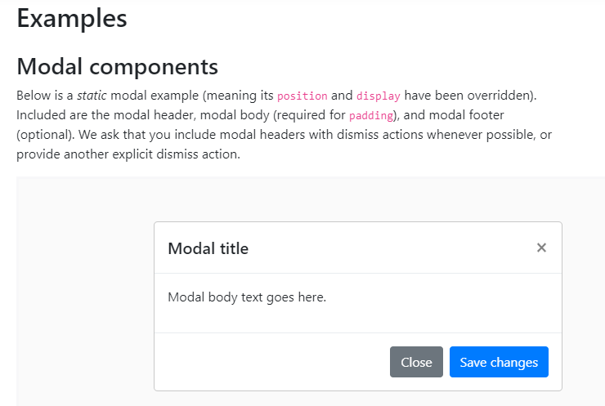

**CODE:**

<div class="modal" tabindex="-1" role="dialog">

<div class="modal-dialog" role="document">

<div class="modal-content">

<div class="modal-header">

<h5 class="modal-title">Modal title</h5>

<button type="button" class="close" data-dismiss="modal" aria-label="Close">

<span aria-hidden="true">&times;</span>

</button>

</div>

<div class="modal-body">

<p>Modal body text goes here.</p>

</div>

<div class="modal-footer">

<button type="button" class="btn btn-primary">Save changes</button>

<button type="button" class="btn btn-secondary" data-dismiss="modal">Close</button>

</div>

</div>

</div>

</div>

**CODE:**

<!-- Button trigger modal -->

<button type="button" class="btn btn-primary" data-toggle="modal" data-target="#exampleModal">

Launch demo modal

</button>

<!-- Modal -->

<div class="modal fade" id="exampleModal" tabindex="-1" role="dialog" aria-labelledby="exampleModalLabel" aria-hidden="true">

<div class="modal-dialog" role="document">

<div class="modal-content">

<div class="modal-header">

<h5 class="modal-title" id="exampleModalLabel">Modal title</h5>

<button type="button" class="close" data-dismiss="modal" aria-label="Close">

<span aria-hidden="true">&times;</span>

</button>

</div>

<div class="modal-body">

...

</div>

<div class="modal-footer">

<button type="button" class="btn btn-secondary" data-dismiss="modal">Close</button>

<button type="button" class="btn btn-primary">Save changes</button>

</div>

</div>

</div>

</div>

**CODE:**

<!-- Button trigger modal -->

<button type="button" class="btn btn-primary" data-toggle="modal" data-target="#exampleModalLong">

Launch demo modal

</button>

<!-- Modal -->

<div class="modal fade" id="exampleModalLong" tabindex="-1" role="dialog" aria-labelledby="exampleModalLongTitle" aria-hidden="true">

<div class="modal-dialog" role="document">

<div class="modal-content">

<div class="modal-header">

<h5 class="modal-title" id="exampleModalLongTitle">Modal title</h5>

<button type="button" class="close" data-dismiss="modal" aria-label="Close">

<span aria-hidden="true">&times;</span>

</button>

</div>

<div class="modal-body">

...

</div>

<div class="modal-footer">

<button type="button" class="btn btn-secondary" data-dismiss="modal">Close</button>

<button type="button" class="btn btn-primary">Save changes</button>

</div>

</div>

</div>

</div>

**CODE:**

<!-- Button trigger modal -->

<button type="button" class="btn btn-primary" data-toggle="modal" data-target="#exampleModalCenter">

Launch demo modal

</button>

<!-- Modal -->

<div class="modal fade" id="exampleModalCenter" tabindex="-1" role="dialog" aria-labelledby="exampleModalCenterTitle" aria-hidden="true">

<div class="modal-dialog modal-dialog-centered" role="document">

<div class="modal-content">

<div class="modal-header">

<h5 class="modal-title" id="exampleModalLongTitle">Modal title</h5>

<button type="button" class="close" data-dismiss="modal" aria-label="Close">

<span aria-hidden="true">&times;</span>

</button>

</div>

<div class="modal-body">

...

</div>

<div class="modal-footer">

<button type="button" class="btn btn-secondary" data-dismiss="modal">Close</button>

<button type="button" class="btn btn-primary">Save changes</button>

</div>

</div>

</div>

</div>

**CODE:**

<div class="modal-body">

<h5>Popover in a modal</h5>

<p>This <a href="#" role="button" class="btn btn-secondary popover-test" title="Popover title" data-content="Popover body content is set in this attribute.">button</a> triggers a popover on click.</p>

<hr>

<h5>Tooltips in a modal</h5>

<p><a href="#" class="tooltip-test" title="Tooltip">This link</a> and <a href="#" class="tooltip-test" title="Tooltip">that link</a> have tooltips on hover.</p>

</div>

**CODE:**

<div class="modal-body">

<div class="container-fluid">

<div class="row">

<div class="col-md-4">.col-md-4</div>

<div class="col-md-4 ml-auto">.col-md-4 .ml-auto</div>

</div>

<div class="row">

<div class="col-md-3 ml-auto">.col-md-3 .ml-auto</div>

<div class="col-md-2 ml-auto">.col-md-2 .ml-auto</div>

</div>

<div class="row">

<div class="col-md-6 ml-auto">.col-md-6 .ml-auto</div>

</div>

<div class="row">

<div class="col-sm-9">

Level 1: .col-sm-9

<div class="row">

<div class="col-8 col-sm-6">

Level 2: .col-8 .col-sm-6

</div>

<div class="col-4 col-sm-6">

Level 2: .col-4 .col-sm-6

</div>

</div>

</div>

</div>

</div>

</div>

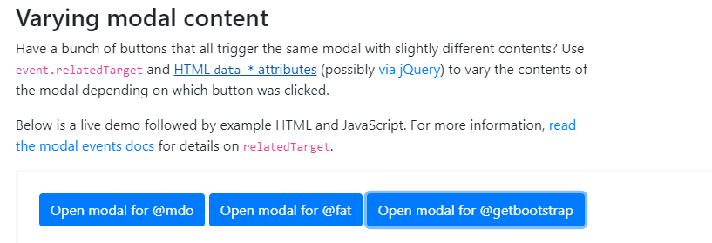

**CODE:**

<button type="button" class="btn btn-primary" data-toggle="modal" data-target="#exampleModal" data-whatever="@mdo">Open modal for @mdo</button>

<button type="button" class="btn btn-primary" data-toggle="modal" data-target="#exampleModal" data-whatever="@fat">Open modal for @fat</button>

<button type="button" class="btn btn-primary" data-toggle="modal" data-target="#exampleModal" data-whatever="@getbootstrap">Open modal for @getbootstrap</button>

<div class="modal fade" id="exampleModal" tabindex="-1" role="dialog" aria-labelledby="exampleModalLabel" aria-hidden="true">

<div class="modal-dialog" role="document">

<div class="modal-content">

<div class="modal-header">

<h5 class="modal-title" id="exampleModalLabel">New message</h5>

<button type="button" class="close" data-dismiss="modal" aria-label="Close">

<span aria-hidden="true">&times;</span>

</button>

</div>

<div class="modal-body">

<form>

<div class="form-group">

<label for="recipient-name" class="col-form-label">Recipient:</label>

<input type="text" class="form-control" id="recipient-name">

</div>

<div class="form-group">

<label for="message-text" class="col-form-label">Message:</label>

<textarea class="form-control" id="message-text"></textarea>

</div>

</form>

</div>

<div class="modal-footer">

<button type="button" class="btn btn-secondary" data-dismiss="modal">Close</button>

<button type="button" class="btn btn-primary">Send message</button>

</div>

</div>

</div>

</div>

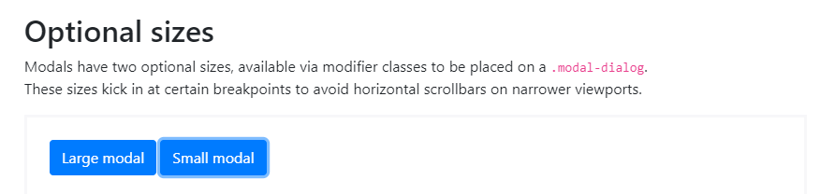

**CODE:**

<!-- Large modal -->

<button type="button" class="btn btn-primary" data-toggle="modal" data-target=".bd-example-modal-lg">Large modal</button>

<div class="modal fade bd-example-modal-lg" tabindex="-1" role="dialog" aria-labelledby="myLargeModalLabel" aria-hidden="true">

<div class="modal-dialog modal-lg">

<div class="modal-content">

...

</div>

</div>

</div>

<!-- Small modal -->

<button type="button" class="btn btn-primary" data-toggle="modal" data-target=".bd-example-modal-sm">Small modal</button>

<div class="modal fade bd-example-modal-sm" tabindex="-1" role="dialog" aria-labelledby="mySmallModalLabel" aria-hidden="true">

<div class="modal-dialog modal-sm">

<div class="modal-content">

...

</div>

</div>

</div>

**NAVS**

**CODE:**

<ul class="nav">

<li class="nav-item">

<a class="nav-link active" href="#">Active</a>

</li>

<li class="nav-item">

<a class="nav-link" href="#">Link</a>

</li>

<li class="nav-item">

<a class="nav-link" href="#">Link</a>

</li>

<li class="nav-item">

<a class="nav-link disabled" href="#">Disabled</a>

</li>

</ul>

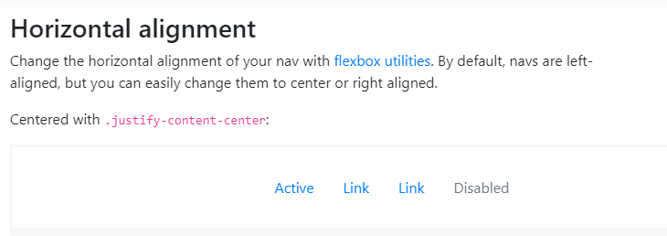

**CODE:**

<ul class="nav justify-content-center">

<li class="nav-item">

<a class="nav-link active" href="#">Active</a>

</li>

<li class="nav-item">

<a class="nav-link" href="#">Link</a>

</li>

<li class="nav-item">

<a class="nav-link" href="#">Link</a>

</li>

<li class="nav-item">

<a class="nav-link disabled" href="#">Disabled</a>

</li>

</ul>

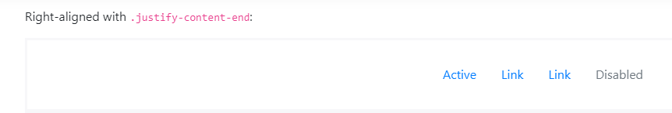

**CODE:**

<ul class="nav justify-content-end">

<li class="nav-item">

<a class="nav-link active" href="#">Active</a>

</li>

<li class="nav-item">

<a class="nav-link" href="#">Link</a>

</li>

<li class="nav-item">

<a class="nav-link" href="#">Link</a>

</li>

<li class="nav-item">

<a class="nav-link disabled" href="#">Disabled</a>

</li>

</ul>

**CODE:**

<ul class="nav flex-column">

<li class="nav-item">

<a class="nav-link active" href="#">Active</a>

</li>

<li class="nav-item">

<a class="nav-link" href="#">Link</a>

</li>

<li class="nav-item">

<a class="nav-link" href="#">Link</a>

</li>

<li class="nav-item">

<a class="nav-link disabled" href="#">Disabled</a>

</li>

</ul>

**CODE:**

<ul class="nav nav-tabs">

<li class="nav-item">

<a class="nav-link active" href="#">Active</a>

</li>

<li class="nav-item">

<a class="nav-link" href="#">Link</a>

</li>

<li class="nav-item">

<a class="nav-link" href="#">Link</a>

</li>

<li class="nav-item">

<a class="nav-link disabled" href="#">Disabled</a>

</li>

</ul>

**CODE:**

<ul class="nav nav-pills">

<li class="nav-item">

<a class="nav-link active" href="#">Active</a>

</li>

<li class="nav-item">

<a class="nav-link" href="#">Link</a>

</li>

<li class="nav-item">

<a class="nav-link" href="#">Link</a>

</li>

<li class="nav-item">

<a class="nav-link disabled" href="#">Disabled</a>

</li>

</ul>

**CODE:**

<ul class="nav nav-pills nav-fill">

<li class="nav-item">

<a class="nav-link active" href="#">Active</a>

</li>

<li class="nav-item">

<a class="nav-link" href="#">Longer nav link</a>

</li>

<li class="nav-item">

<a class="nav-link" href="#">Link</a>

</li>

<li class="nav-item">

<a class="nav-link disabled" href="#">Disabled</a>

</li>

</ul>

**CODE:**

<ul class="nav nav-tabs">

<li class="nav-item">

<a class="nav-link active" href="#">Active</a>

</li>

<li class="nav-item dropdown">

<a class="nav-link dropdown-toggle" data-toggle="dropdown" href="#" role="button" aria-haspopup="true" aria-expanded="false">Dropdown</a>

<div class="dropdown-menu">

<a class="dropdown-item" href="#">Action</a>

<a class="dropdown-item" href="#">Another action</a>

<a class="dropdown-item" href="#">Something else here</a>

<div class="dropdown-divider"></div>

<a class="dropdown-item" href="#">Separated link</a>

</div>

</li>

<li class="nav-item">

<a class="nav-link" href="#">Link</a>

</li>

<li class="nav-item">

<a class="nav-link disabled" href="#">Disabled</a>

</li>

</ul>

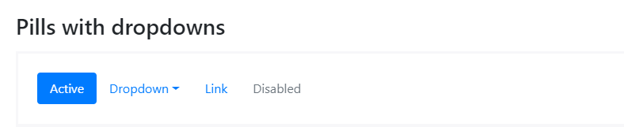

**CODE:**

<ul class="nav nav-pills">

<li class="nav-item">

<a class="nav-link active" href="#">Active</a>

</li>

<li class="nav-item dropdown">

<a class="nav-link dropdown-toggle" data-toggle="dropdown" href="#" role="button" aria-haspopup="true" aria-expanded="false">Dropdown</a>

<div class="dropdown-menu">

<a class="dropdown-item" href="#">Action</a>

<a class="dropdown-item" href="#">Another action</a>

<a class="dropdown-item" href="#">Something else here</a>

<div class="dropdown-divider"></div>

<a class="dropdown-item" href="#">Separated link</a>

</div>

</li>

<li class="nav-item">

<a class="nav-link" href="#">Link</a>

</li>

<li class="nav-item">

<a class="nav-link disabled" href="#">Disabled</a>

</li>

</ul>

**NAVBAR**



**CODE:**

<nav class="navbar navbar-expand-lg navbar-light bg-light">

<a class="navbar-brand" href="#">Navbar</a>

<button class="navbar-toggler" type="button" data-toggle="collapse" data-target="#navbarSupportedContent" aria-controls="navbarSupportedContent" aria-expanded="false" aria-label="Toggle navigation">

<span class="navbar-toggler-icon"></span>

</button>

<div class="collapse navbar-collapse" id="navbarSupportedContent">

<ul class="navbar-nav mr-auto">

<li class="nav-item active">

<a class="nav-link" href="#">Home <span class="sr-only">(current)</span></a>

</li>

<li class="nav-item">

<a class="nav-link" href="#">Link</a>

</li>

<li class="nav-item dropdown">

<a class="nav-link dropdown-toggle" href="#" id="navbarDropdown" role="button" data-toggle="dropdown" aria-haspopup="true" aria-expanded="false">

Dropdown

</a>

<div class="dropdown-menu" aria-labelledby="navbarDropdown">

<a class="dropdown-item" href="#">Action</a>

<a class="dropdown-item" href="#">Another action</a>

<div class="dropdown-divider"></div>

<a class="dropdown-item" href="#">Something else here</a>

</div>

</li>

<li class="nav-item">

<a class="nav-link disabled" href="#">Disabled</a>

</li>

</ul>

<form class="form-inline my-2 my-lg-0">

<input class="form-control mr-sm-2" type="search" placeholder="Search" aria-label="Search">

<button class="btn btn-outline-success my-2 my-sm-0" type="submit">Search</button>

</form>

</div>

</nav>

**CODE:**

<!-- As a link -->

<nav class="navbar navbar-light bg-light">

<a class="navbar-brand" href="#">Navbar</a>

</nav>

<!-- As a heading -->

<nav class="navbar navbar-light bg-light">

<span class="navbar-brand mb-0 h1">Navbar</span>

</nav>

**CODE:**

<!-- Just an image -->

<nav class="navbar navbar-light bg-light">

<a class="navbar-brand" href="#">

<img src="/docs/4.0/assets/brand/bootstrap-solid.svg" width="30" height="30" alt="">

</a>

</nav>



**CODE:**

<!-- Image and text -->

<nav class="navbar navbar-light bg-light">

<a class="navbar-brand" href="#">

<img src="/docs/4.0/assets/brand/bootstrap-solid.svg" width="30" height="30" class="d-inline-block align-top" alt="">

Bootstrap

</a>

</nav>

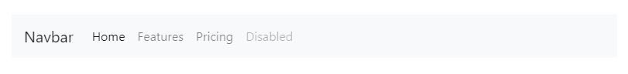

**CODE:**

<nav class="navbar navbar-expand-lg navbar-light bg-light">

<a class="navbar-brand" href="#">Navbar</a>

<button class="navbar-toggler" type="button" data-toggle="collapse" data-target="#navbarNav" aria-controls="navbarNav" aria-expanded="false" aria-label="Toggle navigation">

<span class="navbar-toggler-icon"></span>

</button>

<div class="collapse navbar-collapse" id="navbarNav">

<ul class="navbar-nav">

<li class="nav-item active">

<a class="nav-link" href="#">Home <span class="sr-only">(current)</span></a>

</li>

<li class="nav-item">

<a class="nav-link" href="#">Features</a>

</li>

<li class="nav-item">

<a class="nav-link" href="#">Pricing</a>

</li>

<li class="nav-item">

<a class="nav-link disabled" href="#">Disabled</a>

</li>

</ul>

</div>

</nav>

**CODE:**

<nav class="navbar navbar-light bg-light">

<form class="form-inline">

<input class="form-control mr-sm-2" type="search" placeholder="Search" aria-label="Search">

<button class="btn btn-outline-success my-2 my-sm-0" type="submit">Search</button>

</form>

</nav>

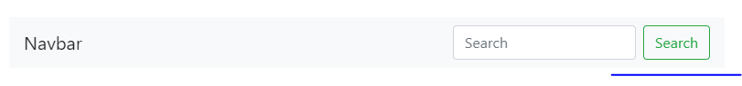

**CODE:**

<nav class="navbar navbar-light bg-light justify-content-between">

<a class="navbar-brand">Navbar</a>

<form class="form-inline">

<input class="form-control mr-sm-2" type="search" placeholder="Search" aria-label="Search">

<button class="btn btn-outline-success my-2 my-sm-0" type="submit">Search</button>

</form>

</nav>

**CODE:**

<nav class="navbar navbar-light bg-light">

<form class="form-inline">

<div class="input-group">

<div class="input-group-prepend">

<span class="input-group-text" id="basic-addon1">@</span>

</div>

<input type="text" class="form-control" placeholder="Username" aria-label="Username" aria-describedby="basic-addon1">

</div>

</form>

</nav>

**CODE:**

<nav class="navbar navbar-light bg-light">

<form class="form-inline">

<button class="btn btn-outline-success" type="button">Main button</button>

<button class="btn btn-sm btn-outline-secondary" type="button">Smaller button</button>

</form>

</nav>

**CODE:**

<nav class="navbar navbar-light bg-light">

<span class="navbar-text">

Navbar text with an inline element

</span>

</nav>

**CODE:**

<nav class="navbar navbar-expand-lg navbar-light bg-light">

<a class="navbar-brand" href="#">Navbar w/ text</a>

<button class="navbar-toggler" type="button" data-toggle="collapse" data-target="#navbarText" aria-controls="navbarText" aria-expanded="false" aria-label="Toggle navigation">

<span class="navbar-toggler-icon"></span>

</button>

<div class="collapse navbar-collapse" id="navbarText">

<ul class="navbar-nav mr-auto">

<li class="nav-item active">

<a class="nav-link" href="#">Home <span class="sr-only">(current)</span></a>

</li>

<li class="nav-item">

<a class="nav-link" href="#">Features</a>

</li>

<li class="nav-item">

<a class="nav-link" href="#">Pricing</a>

</li>

</ul>

<span class="navbar-text">

Navbar text with an inline element

</span>

</div>

</nav>

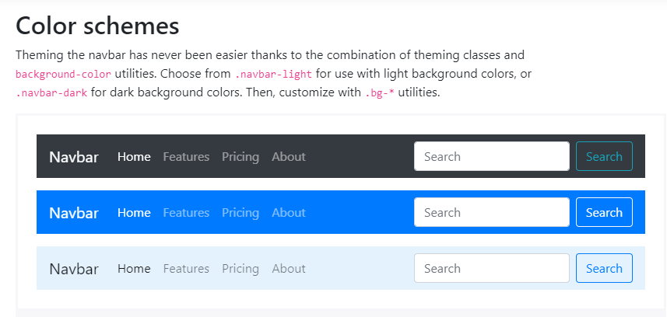

**CODE:**

<nav class="navbar navbar-dark bg-dark">

<!-- Navbar content -->

</nav>

<nav class="navbar navbar-dark bg-primary">

<!-- Navbar content -->

</nav>

<nav class="navbar navbar-light" style="background-color: #e3f2fd;">

<!-- Navbar content -->

</nav>

**CODE:**

<div class="container">

<nav class="navbar navbar-expand-lg navbar-light bg-light">

<a class="navbar-brand" href="#">Navbar</a>

</nav>

</div>

## **Placement**

Use our [position utilities](https://getbootstrap.com/docs/4.0/utilities/position/) to place navbars in non-static positions. Choose from fixed to the top, fixed to the bottom, or stickied to the top (scrolls with the page until it reaches the top, then stays there). Fixed navbars use position: fixed, meaning they’re pulled from the normal flow of the DOM and may require custom CSS (e.g., padding-top on the <body>) to prevent overlap with other elements.

Also note that **.sticky-top uses position: sticky, which**[**isn’t fully supported in every browser**](https://caniuse.com/#feat=css-sticky).

[Default](https://getbootstrap.com/docs/4.0/components/navbar/)

Copy

<nav class="navbar navbar-light bg-light">

<a class="navbar-brand" href="#">Default</a>

</nav>

[Fixed top](https://getbootstrap.com/docs/4.0/components/navbar/)

Copy

<nav class="navbar fixed-top navbar-light bg-light">

<a class="navbar-brand" href="#">Fixed top</a>

</nav>

[Fixed bottom](https://getbootstrap.com/docs/4.0/components/navbar/)

Copy

<nav class="navbar fixed-bottom navbar-light bg-light">

<a class="navbar-brand" href="#">Fixed bottom</a>

</nav>

[Sticky top](https://getbootstrap.com/docs/4.0/components/navbar/)

Copy

<nav class="navbar sticky-top navbar-light bg-light">

<a class="navbar-brand" href="#">Sticky top</a>

</nav>

**CODE:**

<div class="pos-f-t">

<div class="collapse" id="navbarToggleExternalContent">

<div class="bg-dark p-4">

<h4 class="text-white">Collapsed content</h4>

<span class="text-muted">Toggleable via the navbar brand.</span>

</div>

</div>

<nav class="navbar navbar-dark bg-dark">

<button class="navbar-toggler" type="button" data-toggle="collapse" data-target="#navbarToggleExternalContent" aria-controls="navbarToggleExternalContent" aria-expanded="false" aria-label="Toggle navigation">

<span class="navbar-toggler-icon"></span>

</button>

</nav>

</div>

**PAGINATION**

**CODE:**

<nav aria-label="Page navigation example">

<ul class="pagination">

<li class="page-item"><a class="page-link" href="#">Previous</a></li>

<li class="page-item"><a class="page-link" href="#">1</a></li>

<li class="page-item"><a class="page-link" href="#">2</a></li>

<li class="page-item"><a class="page-link" href="#">3</a></li>

<li class="page-item"><a class="page-link" href="#">Next</a></li>

</ul>

</nav>

**CODE:**

<nav aria-label="Page navigation example">

<ul class="pagination">

<li class="page-item">

<a class="page-link" href="#" aria-label="Previous">

<span aria-hidden="true">&laquo;</span>

<span class="sr-only">Previous</span>

</a>

</li>

<li class="page-item"><a class="page-link" href="#">1</a></li>

<li class="page-item"><a class="page-link" href="#">2</a></li>

<li class="page-item"><a class="page-link" href="#">3</a></li>

<li class="page-item">

<a class="page-link" href="#" aria-label="Next">

<span aria-hidden="true">&raquo;</span>

<span class="sr-only">Next</span>

</a>

</li>

</ul>

</nav>

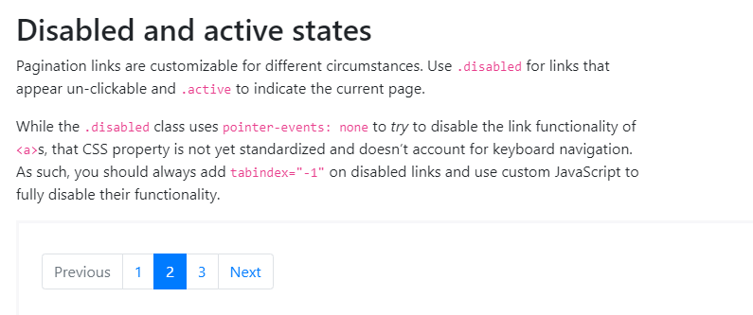

**CODE:**

<nav aria-label="...">

<ul class="pagination">

<li class="page-item disabled">

<a class="page-link" href="#" tabindex="-1">Previous</a>

</li>

<li class="page-item"><a class="page-link" href="#">1</a></li>

<li class="page-item active">

<a class="page-link" href="#">2 <span class="sr-only">(current)</span></a>

</li>

<li class="page-item"><a class="page-link" href="#">3</a></li>

<li class="page-item">

<a class="page-link" href="#">Next</a>

</li>

</ul>

</nav>

**CODE:**

<nav aria-label="...">

<ul class="pagination pagination-lg">

<li class="page-item disabled">

<a class="page-link" href="#" tabindex="-1">1</a>

</li>

<li class="page-item"><a class="page-link" href="#">2</a></li>

<li class="page-item"><a class="page-link" href="#">3</a></li>

</ul>

</nav>

**CODE:**

<nav aria-label="...">

<ul class="pagination pagination-sm">

<li class="page-item disabled">

<a class="page-link" href="#" tabindex="-1">1</a>

</li>

<li class="page-item"><a class="page-link" href="#">2</a></li>

<li class="page-item"><a class="page-link" href="#">3</a></li>

</ul>

</nav>

**CODE:**

<nav aria-label="Page navigation example">

<ul class="pagination justify-content-center">

<li class="page-item disabled">

<a class="page-link" href="#" tabindex="-1">Previous</a>

</li>

<li class="page-item"><a class="page-link" href="#">1</a></li>

<li class="page-item"><a class="page-link" href="#">2</a></li>

<li class="page-item"><a class="page-link" href="#">3</a></li>

<li class="page-item">

<a class="page-link" href="#">Next</a>

</li>

</ul>

</nav>

**CODE:**

<nav aria-label="Page navigation example">

<ul class="pagination justify-content-end">

<li class="page-item disabled">

<a class="page-link" href="#" tabindex="-1">Previous</a>

</li>

<li class="page-item"><a class="page-link" href="#">1</a></li>

<li class="page-item"><a class="page-link" href="#">2</a></li>

<li class="page-item"><a class="page-link" href="#">3</a></li>

<li class="page-item">

<a class="page-link" href="#">Next</a>

</li>

</ul>

</nav>

**POPOVERS**

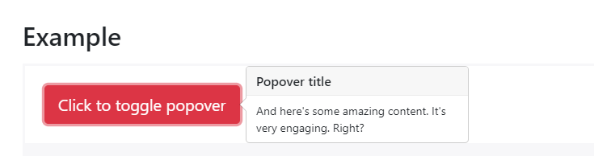

**CODE:**

<button type="button" class="btn btn-lg btn-danger" data-toggle="popover" title="Popover title" data-content="And here's some amazing content. It's very engaging. Right?">Click to toggle popover</button>

**CODE:**

<button type="button" class="btn btn-secondary" data-container="body" data-toggle="popover" data-placement="top" data-content="Vivamus sagittis lacus vel augue laoreet rutrum faucibus.">

Popover on top

</button>

<button type="button" class="btn btn-secondary" data-container="body" data-toggle="popover" data-placement="right" data-content="Vivamus sagittis lacus vel augue laoreet rutrum faucibus.">

Popover on right

</button>

<button type="button" class="btn btn-secondary" data-container="body" data-toggle="popover" data-placement="bottom" data-content="Vivamus

sagittis lacus vel augue laoreet rutrum faucibus.">

Popover on bottom

</button>

<button type="button" class="btn btn-secondary" data-container="body" data-toggle="popover" data-placement="left" data-content="Vivamus sagittis lacus vel augue laoreet rutrum faucibus.">

Popover on left

</button>

# **Progress**

Documentation and examples for using Bootstrap custom progress bars featuring support for stacked bars, animated backgrounds, and text labels.

**CODE:**

<div class="progress">

<div class="progress-bar" role="progressbar" aria-valuenow="0" aria-valuemin="0" aria-valuemax="100"></div>

</div>

<div class="progress">

<div class="progress-bar" role="progressbar" style="width: 25%" aria-valuenow="25" aria-valuemin="0" aria-valuemax="100"></div>

</div>

<div class="progress">

<div class="progress-bar" role="progressbar" style="width: 50%" aria-valuenow="50" aria-valuemin="0" aria-valuemax="100"></div>

</div>

<div class="progress">

<div class="progress-bar" role="progressbar" style="width: 75%" aria-valuenow="75" aria-valuemin="0" aria-valuemax="100"></div>

</div>

<div class="progress">

<div class="progress-bar" role="progressbar" style="width: 100%" aria-valuenow="100" aria-valuemin="0" aria-valuemax="100"></div>

</div>

**CODE:**

<div class="progress">

<div class="progress-bar w-75" role="progressbar" aria-valuenow="75" aria-valuemin="0" aria-valuemax="100"></div>

</div>

**CODE:**

<div class="progress">

<div class="progress-bar" role="progressbar" style="width: 25%;" aria-valuenow="25" aria-valuemin="0" aria-valuemax="100">25%</div>

</div>

**CODE:**

<div class="progress" style="height: 1px;">

<div class="progress-bar" role="progressbar" style="width: 25%;" aria-valuenow="25" aria-valuemin="0" aria-valuemax="100"></div>

</div>

<div class="progress" style="height: 20px;">

<div class="progress-bar" role="progressbar" style="width: 25%;" aria-valuenow="25" aria-valuemin="0" aria-valuemax="100"></div>

</div>

**CODE:**

<div class="progress">

<div class="progress-bar bg-success" role="progressbar" style="width: 25%" aria-valuenow="25" aria-valuemin="0" aria-valuemax="100"></div>

</div>

<div class="progress">

<div class="progress-bar bg-info" role="progressbar" style="width: 50%" aria-valuenow="50" aria-valuemin="0" aria-valuemax="100"></div>

</div>

<div class="progress">

<div class="progress-bar bg-warning" role="progressbar" style="width: 75%" aria-valuenow="75" aria-valuemin="0" aria-valuemax="100"></div>

</div>

<div class="progress">

<div class="progress-bar bg-danger" role="progressbar" style="width: 100%" aria-valuenow="100" aria-valuemin="0" aria-valuemax="100"></div>

</div>

**CODE:**

<div class="progress">

<div class="progress-bar" role="progressbar" style="width: 15%" aria-valuenow="15" aria-valuemin="0" aria-valuemax="100"></div>

<div class="progress-bar bg-success" role="progressbar" style="width: 30%" aria-valuenow="30" aria-valuemin="0" aria-valuemax="100"></div>

<div class="progress-bar bg-info" role="progressbar" style="width: 20%" aria-valuenow="20" aria-valuemin="0" aria-valuemax="100"></div>

</div>

**CODE:**

<div class="progress">

<div class="progress-bar progress-bar-striped" role="progressbar" style="width: 10%" aria-valuenow="10" aria-valuemin="0" aria-valuemax="100"></div>

</div>

<div class="progress">

<div class="progress-bar progress-bar-striped bg-success" role="progressbar" style="width: 25%" aria-valuenow="25" aria-valuemin="0" aria-valuemax="100"></div>

</div>

<div class="progress">

<div class="progress-bar progress-bar-striped bg-info" role="progressbar" style="width: 50%" aria-valuenow="50" aria-valuemin="0" aria-valuemax="100"></div>

</div>

<div class="progress">

<div class="progress-bar progress-bar-striped bg-warning" role="progressbar" style="width: 75%" aria-valuenow="75" aria-valuemin="0" aria-valuemax="100"></div>

</div>

<div class="progress">

<div class="progress-bar progress-bar-striped bg-danger" role="progressbar" style="width: 100%" aria-valuenow="100" aria-valuemin="0" aria-valuemax="100"></div>

</div>

**CODE:**

<div class="progress">

<div class="progress-bar progress-bar-striped progress-bar-animated" role="progressbar" aria-valuenow="75" aria-valuemin="0" aria-valuemax="100" style="width: 75%"></div>

</div>

# **Scrollspy**

Automatically update Bootstrap navigation or list group components based on scroll position to indicate which link is currently active in the viewport.

**CODE:**

<nav id="navbar-example2" class="navbar navbar-light bg-light">

<a class="navbar-brand" href="#">Navbar</a>

<ul class="nav nav-pills">

<li class="nav-item">

<a class="nav-link" href="#fat">@fat</a>

</li>

<li class="nav-item">

<a class="nav-link" href="#mdo">@mdo</a>

</li>

<li class="nav-item dropdown">

<a class="nav-link dropdown-toggle" data-toggle="dropdown" href="#" role="button" aria-haspopup="true" aria-expanded="false">Dropdown</a>

<div class="dropdown-menu">

<a class="dropdown-item" href="#one">one</a>

<a class="dropdown-item" href="#two">two</a>

<div role="separator" class="dropdown-divider"></div>

<a class="dropdown-item" href="#three">three</a>

</div>

</li>

</ul>

</nav>

<div data-spy="scroll" data-target="#navbar-example2" data-offset="0">

<h4 id="fat">@fat</h4>

<p>...</p>

<h4 id="mdo">@mdo</h4>

<p>...</p>

<h4 id="one">one</h4>

<p>...</p>

<h4 id="two">two</h4>

<p>...</p>

<h4 id="three">three</h4>

<p>...</p>

</div>

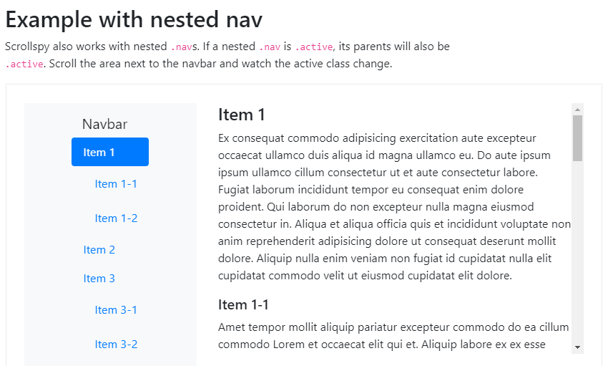

**CODE:**

<nav id="navbar-example3" class="navbar navbar-light bg-light">

<a class="navbar-brand" href="#">Navbar</a>

<nav class="nav nav-pills flex-column">

<a class="nav-link" href="#item-1">Item 1</a>

<nav class="nav nav-pills flex-column">

<a class="nav-link ml-3 my-1" href="#item-1-1">Item 1-1</a>

<a class="nav-link ml-3 my-1" href="#item-1-2">Item 1-2</a>

</nav>

<a class="nav-link" href="#item-2">Item2</a>

<a class="nav-link" href="#item-3">Item3</a>

<nav class="nav nav-pills flex-column">

<a class="nav-link ml-3 my-1" href="#item-3-1">Item 3-1</a>

<a class="nav-link ml-3 my-1" href="#item-3-2">Item 3-2</a>

</nav>

</nav>

</nav>

<div data-spy="scroll" data-target="#navbar-example3" data-offset="0">

<h4 id="item-1">Item 1</h4>

<p>...</p>

<h5 id="item-1-1">Item 1-1</h5>

<p>...</p>

<h5 id="item-1-2">Item 2-2</h5>

<p>...</p>

<h4 id="item-2">Item 2</h4>

<p>...</p>

<h4 id="item-3">Item 3</h4>

<p>...</p>

<h5 id="item-3-1">Item 3-1</h5>

<p>...</p>

<h5 id="item-3-2">Item 3-2</h5>

<p>...</p>

</div>

**CODE:**

<div id="list-example" class="list-group">

<a class="list-group-item list-group-item-action" href="#list-item-1">Item 1</a>

<a class="list-group-item list-group-item-action" href="#list-item-2">Item2</a>

<a class="list-group-item list-group-item-action" href="#list-item-3">Item 3</a>

<a class="list-group-item list-group-item-action" href="#list-item-4">Item 4</a>

</div>

<div data-spy="scroll" data-target="#list-example" data-offset="0" class="scrollspy-example">

<h4 id="list-item-1">Item 1</h4>

<p>...</p>

<h4 id="list-item-2">Item 2</h4>

<p>...</p>

<h4 id="list-item-3">Item 3</h4>

<p>...</p>

<h4 id="list-item-4">Item 4</h4>

<p>...</p>

</div>

# **Tooltips**

Documentation and examples for adding custom Bootstrap tooltips with CSS and JavaScript using CSS3 for animations and data-attributes for local title storage.

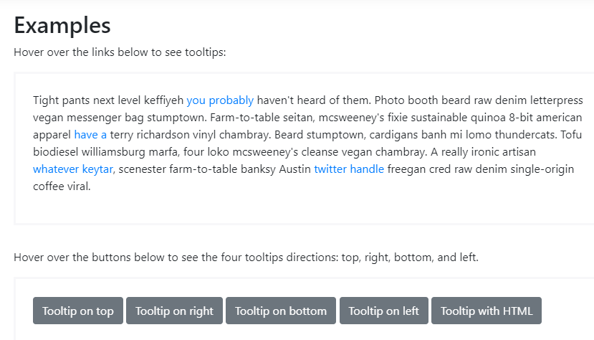

**CODE:**

<button type="button" class="btn btn-secondary" data-toggle="tooltip" data-placement="top" title="Tooltip on top">

Tooltip on top

</button>

<button type="button" class="btn btn-secondary" data-toggle="tooltip" data-placement="right" title="Tooltip on right">

Tooltip on right

</button>

<button type="button" class="btn btn-secondary" data-toggle="tooltip" data-placement="bottom" title="Tooltip on bottom">

Tooltip on bottom

</button>

<button type="button" class="btn btn-secondary" data-toggle="tooltip" data-placement="left" title="Tooltip on left">

Tooltip on left

</button>

**CODE:**

<span class="d-inline-block" tabindex="0" data-toggle="tooltip" title="Disabled tooltip">

<button class="btn btn-primary" style="pointer-events: none;" type="button" disabled>Disabled button</button>

</span>